LNDN11133-Business Research Project

Waste management and Improving Customer experience at Sainsbury's Low Hall Walthamstow Store.

**Supervisor Name:**

**Student Name: Pratheesh Prasad**

**Banner ID:**

**Abstract**

This dissertation examines how Sainsbury's Low Hall Walthamstow may improve the shopping experience for its consumers and its bottom line by focusing on waste management and the sale of almost expired products. Qualitative methods were used, and data was gathered from 18 individuals through questionnaires and in-depth interviews.

The results of the survey show that customers have strong opinions on product quality, pricing, and the interactions they have with staff. Customers appreciated the store's accessibility, friendliness, and ability to fulfil their needs. Concerns were raised regarding the items' pricing and quality, revealing possible weak points.

The sale of perishable foods provided an opportunity to save money and cut down on food waste. Customers' shown willingness to purchase such items at discounted prices is indicative of wins for the company and the customers alike. It is emphasised that employees have a significant role in shaping customers' experiences, and it is proposed that training and recognition initiatives for employees be financed to enhance interactions.

Customers shopped there because of a number of positive aspects, including affordable costs, easy accessibility, and friendly service. Future planning may be more responsive to customer requirements if this information is available. Leadership is also emphasised for its significance in promoting customer-centric practises and responding to varying consumer expectations.

The study has practical ramifications for the Low Hall Walthamstow Sainsbury's by suggesting ways to improve product quality, pricing, and employee engagement. The study also highlights the potential of delivering commodities near their expiration dates to reduce waste and improve income. Tuning operations to the demands of customers and using effective strategies may increase customer pleasure, loyalty, and the store's bottom line.

Contents

Chapter 1: Introduction 3

1.1 Introduction 3

1.2 Research Objectives 4

1.3 Research Questions 5

1.4 Literature Review: 5

1.5 Methodology: 7

1.6 Ethical Considerations: 8

Chapter 2: Literature Review 8

2.1 Current Customer Experience and Areas for Improvement 8

2.2 Effectiveness of Strategies and Initiatives to Increase Revenue 10

2.3 Impact on the Local Community and Social/Cultural Significance 13

2.4 Role of Technology in Enhancing Customer Experience and Efficiency 15

2.5 Meeting the Changing Needs of Diverse Customers in the UK Retail Industry 17

Chapter 3: Methodology 18

3.1 Introduction 18

3.2 Research Design 19

3.3 Research Philosophy 21

3.4 Research Approach 22

3.5 Sampling Strategy 23

3.6 Data Collection 24

3.7 Data Analysis 25

3.8 Ethical Considerations 25

3.9 Validity and Reliability 26

3.10 Limitations 27

3.11 Scope 27

3.12 Conclusion 28

Chapter 4: Findings and Results 28

4.1 Customer Satisfaction 28

4.2 Product Quality and Pricing 30

4.3 Near Expiry Foods 31

4.4 Reasons for Choosing the Store 33

4.5 Return Policy and Shopping Experience 34

4.6 Employee Engagement and Customer Interactions 36

Chapter 5: Conclusion and Discussion 37

5.1 Summary of Findings 37

5.2 Employee Engagement and Customer Interactions 38

5.3 Product Quality and Pricing 39

5.4 Near Expiry Foods 40

5.5 Reasons for Choosing the Store 41

5.6 Return Policy and Shopping Experience 42

5.7 Discussion and Implications 43

5.8 Wrapping Up 43

References 45

**Chapter 1: Introduction**

## 1.1 Introduction

Businesses in the UK's retail sector are in a cutthroat race to keep up with customers' ever-evolving wants and needs. Sainsbury's is a good example of a company that has consistently been ahead of the retail innovation curve. The Walthamstow, London Sainsbury's shop is the subject of this dissertation.

Sainsbury's Walthamstow faces a commercial challenge in maintaining customer satisfaction and staying ahead of the competition.

This study has significant practical and economic implications. Sainsbury's is one of the greatest grocery chains in the United Kingdom, and its prosperity is essential to the retail sector as a whole. Sainsbury's Walthamstow caters to a large and varied customer base, hence the findings of this study have broader societal implications. Learning from Sainsbury's Walthamstow's approach to meeting these demands will help other stores better fulfil their customers' expectations (Kirby, A., 2008).

This case study is particularly useful because of the unique characteristics and high standards of the Walthamstow area, which call for tailored strategies to meet the preferences of the resident population.

Sainsbury's Walthamstow employees, supervisors, and regulars will all have a hand in this endeavour. Questionnaires, and statistical analysis will all contribute to the study.

The Sainsbury's Walthamstow store is conveniently located in the middle of this dynamic East London neighbourhood. Because of its location and clientele, the store provides a useful example of how businesses may adjust to meet the needs of a diverse audience. Alternative data collection strategies should be used if face-to-face interviews or surveys are impractical or if participants are unable to offer information voluntarily. Methods that don't need identifying participants include observational studies, analyses of recent consumer comments or reviews, and anonymous internet questionnaires (Jackson, A.A., 2018).

This dissertation will provide an in-depth analysis of the strategies Sainsbury's Walthamstow has employed to remain a market leader while also catering to its customers' evolving tastes. Implications for British business owners are substantial in light of the study's conclusions.

## 1.2 Research Objectives

1. To determine how satisfied existing and potential customers are with the services offered at Sainsbury's Low Hall Walthamstow location.
2. The goal of this study is to learn how different product qualities and price points affect consumers' opinions and decisions.
3. To investigate the feasibility of minimising food waste and increasing profits by selling items close to their expiration dates at reduced costs.
4. The goal of this research is to determine how staff involvement and interactions with customers affect customer experiences and loyalty.

## Research Questions

1. How satisfied are existing and potential customers with the services offered at Sainsbury's Low Hall Walthamstow location?
2. What effects do product quality and cost have on shoppers' impressions and decisions?
3. How do people feel about paying a reduced price for food that is about to go bad?
4. How can we increase customer experiences and loyalty by boosting employee engagement and connection with customers?
5. How may supplying items close to their expiration date help cut down on food waste while also bringing in more money for the grocery store?

## 1.4 Literature Review:

There have been many shifts in the retail sector as businesses struggle to keep up with customers' ever-evolving demands and preferences. Supermarkets like Sainsbury's are feeling the effects of rising rivalry from budget shops and online food delivery services (Xiao et al., 2021).

The satisfaction of a store's clientele has been proved to be an important indicator of that store's financial health. Customers are more likely to be loyal and patronise a company again if they have a good experience, but they are less likely to do so if they have a poor one. Therefore, it is essential for Sainsbury's and other retailers to place a premium on providing a pleasant and stress-free shopping experience for their customers (Ali et al., 2021).

Retailers may use technology to better serve their customers in a number of ways. Self-service check-out and other mobile payment alternatives, for instance, can speed up service and decrease client wait times. There might also be a human-operated counter available for those consumers who would rather not deal with the automated system. Moreover, data analytics may be utilised to tailor both the shopping and browsing experiences to each individual client (Lever, J, 2010).

Sainsbury's Walthamstow caters to a multicultural neighbourhood with a wide range of tastes and requirements. The success of the shop depends on its ability to anticipate and cater to these wants and tastes. Community service may help retailers increase their bottom line, but profit maximisation is what drives them. By understanding and fulfilling the needs of the neighbourhood as a whole, retailers may boost customer loyalty, the quality of their customers' shopping experiences, their access to niche markets, and the longevity of their business (Toynbee, P. and Walker, D., 2015). Engaging with the community, funding local initiatives, and focusing on social and environmental concerns all contribute to a positive brand image, increased consumer loyalty, increased customer patronage, and increased revenue growth for a business. As a result, there may be mutual gains for the store and the neighbourhood if the shop's mission and the neighborhood's needs are aligned (Pearson, D., 2013).

Sainsbury's Walthamstow is one of the many local companies that play an essential role by generating jobs and boosting the economy. They may also be important parts of the local culture by providing meeting areas for residents.

According to the research, stores like Sainsbury's need to prioritise the needs and preferences of their communities, as well as provide a convenient and personalised shopping experience for its customers by leveraging technology. It is also vital to recognise the social and cultural contributions made by many retail establishments (Westman et al., 2018).

## 1.5 Methodology:

This study focuses on investigating the methods utilized by Sainsbury's Walthamstow to enhance customer shopping experiences, increase profitability, and maintain its competitive advantage. The research design exclusively relies on survey-based data collection methods, employing both qualitative and quantitative techniques to gather information (Dawadi et al., 2021).

To obtain qualitative insights, no interviews or focus groups were conducted. Instead, Sainsbury's Walthamstow employees and management were not directly involved in the data collection process. Instead, a survey was distributed to regular customers, aiming to gauge their levels of contentment, loyalty, and preferences both in-store and online.

Thematic analysis and descriptive statistics will be used to analyze the data gathered from the surveys. Thematic analysis will help identify recurring themes and patterns in the qualitative data, while descriptive statistics will be employed to summarize the numerical data for better understanding (Dawadi et al., 2021).

One potential limitation of the study is the risk of social desirability bias in the survey responses, where respondents might provide answers they perceive as socially acceptable rather than expressing their genuine opinions. Additionally, due to the survey-based approach, the sample size may not be fully representative of Sainsbury's Walthamstow's entire customer base.

In conclusion, this mixed-methods research solely relies on survey-based data collection, offering valuable insights into the ways Sainsbury's Walthamstow can improve customer experiences and optimize waste management practices. By using surveys, the study gains comprehensive information from employees, managers, and customers to facilitate data analysis and derive meaningful implications for the store's success.

## 1.6 Ethical Considerations:

All research projects, including this dissertation, must take ethical issues into account. All research participants will provide informed permission to guarantee compliance with ethical guidelines (Naufel & Edwards, 2022). All possible risks and advantages, as well as the research's purpose, will be made clear to participants. In addition, we will erase any personally identifiable information from the data we gather before analysing it, so you can rest certain that your privacy will be protected. Finally, the research will be done in accordance with the rules established by the University's Research Ethics Committee and the British Psychological Society (BPS).

# 

# Chapter 2: Literature Review

An important part of this dissertation is the literature review, which will investigate and synthesise previous research on Sainsbury's Low Hall Walthamstow store's waste management practises, customers' perceptions, and environmentally responsible shopping. This chapter lays the groundwork for the ongoing study by doing a thorough assessment of the present state of knowledge in the topic and highlighting any gaps that should be filled by future research.

In recent years, waste management practises have under more scrutiny as businesses look for new ways to lessen their impact on the environment. A positive customer experience is crucial to a store's success since it encourages repeat business and word-of-mouth promotion. If stores want to give their customers an enjoyable and memorable shopping experience, they need to know what makes their customers happy.

The notion of sustainable retailing has arisen as a prominent topic of interest for both retailers and scholars in response to rising customer awareness and expectations for sustainability. For businesses to see the value in embracing environmentally friendly initiatives, they must first understand how sustainable practises affect consumer behaviour and financial performance (Mehta, N., 2022).

Leadership and employee buy-in are also crucial to achieving waste reduction and sustainable business practises. Leadership that encourages staff to reduce waste and deliver excellent service to customers is essential in creating a sustainable culture.

By conducting this literature review, we hope to better understand the opportunities and challenges faced by Sainsbury's Low Hall Walthamstow location in its pursuit of waste reduction, improved customer experiences, and sustainable retailing practises by critically analysing existing studies, identifying knowledge gaps, and providing concrete examples. This dissertation uses this corpus of research to further our knowledge of retail waste management and sustainability (Fearne, A., 2006) and perhaps shed new light on the subject.

**2.1 Waste Management Practices in Retail:**

Because of the economic and ecological costs associated with improper trash disposal, the retail sector has made it a top priority to find effective solutions. To reduce their negative impact on the environment and boost their standing as upstanding members of the community, retailers are increasingly under pressure to implement efficient waste management policies. This part of the literature study examines the most prominent methods of retail trash management, with attention paid to Sainsbury's Low Hall Walthamstow location in particular.

Retailers have implemented waste management practises to reduce food waste as one of their top priorities. The retail industry is responsible for a significant portion of the nation's yearly food waste. Like many other supermarkets, Sainsbury's Low Hall Walthamstow has participated in programmes designed to reduce food waste. To cut down on waste and overstocking, businesses can use better stock management solutions like just-in-time inventory control. In order to prevent perfectly edible food from going to waste, the store may work with local food pantries to disperse any overstock (de Visser-Amundson, A, 2020).

Recycling products is an important part of retail waste management. Like many other stores, Sainsbury's Low Hall Walthamstow is dedicated to recycling non-food items such as paper, cardboard, plastic, and glass. Businesses may do their part in promoting recycling by providing recycling containers for consumers and staff. Furthermore, as part of the store's dedication to sustainability, recyclable or biodegradable packaging materials are being used more frequently.

Additionally, energy saving practises are frequently included into waste reduction strategies. Energy-efficient solutions, like as LED lighting and state-of-the-art HVAC systems, might be used by stores like Sainsbury's Low Hall Walthamstow. The shop is showing the economic benefits of sustainable practises by cutting its energy use, which helps reduce waste and decreases operating expenses.

More and more people are turning to waste-to-energy technology as a way to handle garbage in a greener fashion. Biogas and electricity are only two examples of the energy sources that may be created using these technology. Retailers might benefit from these technologies in the long run by adopting more thorough waste management practises (Keiningham, T., 2020).

Sainsbury's Low Hall Walthamstow store is a good example of how retailers may address environmental concerns and consumer needs for sustainable operations by using waste management practises. Retailers may greatly lessen their negative effects on the environment by measures such as reducing food waste, recycling, conserving energy, and investigating novel waste-to-energy technologies. These actions not only help the environment, but also boost the store's credibility and patronage, making it a frontrunner in the field of sustainable retailing.

**2.2 Customer Experiences and Satisfaction:**

Retailers like Sainsbury's Low Hall Walthamstow place a premium on customer service since their patronage is crucial to their success and survival. In this portion of the literature study, we examine the significance of customers' perceptions and happiness with their shopping experiences to the retail sector generally, and with Sainsbury's in particular.

The foundation of a profitable retail business is providing exceptional service to customers. Customers are more inclined to shop there again and tell their friends about it if they had a good experience there. Sainsbury's Low Hall Walthamstow, like other market leaders, is committed to offering superior service to its clientele (Gislason, H., 2000).

Customers' opinions of the shop as a whole are influenced by the kind of service they get there. In order to better serve their customers, many shops provide their staff members chances for training and advancement. Employees that are helpful, polite, and willing to go the extra mile for customers are more likely to retain those customers and receive positive feedback.

In addition, the business's design and layout greatly affect how customers perceive the store. Stores like Sainsbury's Low Hall Walthamstow, and others like it, put a lot of thought into how they arrange their products and aisles to provide customers the best possible experience. Well-designed signage, intuitive product placement, and aesthetically pleasing displays all contribute to a more positive shopping experience for customers.

Customer service in retail has also been transformed by the digital revolution. Technology is being used by stores like Sainsbury's to improve the shopping experience for customers. Retailers are adapting to the changing buying habits of their customers through a variety of channels, including online stores, smartphone applications, and digital loyalty programmes.

Meeting and surpassing customer expectations is key to maintaining happy customers. In order to meet their customers' expectations, retailers make an effort to learn about their wants and requirements. In order to continually enhance their services and address any areas of concern, businesses like Sainsbury's Low Hall Walthamstow may undertake customer surveys and analyse feedback (Hughes, D. and Merton, 1996).

There is a strong correlation between pricing tactics and client happiness. Offering low pricing while yet turning a profit is a balancing act that all retailers must master. To attract budget-conscious shoppers and improve overall satisfaction, Sainsbury's may utilise a variety of pricing strategies, including discounts, promotions, and loyalty awards.

**2.3 Sustainable Retailing and Customer Behavior:**

Concern and knowledge about the need of maintaining a healthy ecosystem have increased in recent years. This trend may be seen in the growing demand for eco-friendly and sustainable products among today's customers. Focusing on how Sainsbury's Low Hall Walthamstow and other retailers are adapting to these shifting consumer demands, this portion of the literature review analyses the notion of sustainable retailing and its impact on customer behaviour (Styles, D., 2012).

The term "sustainable retailing" is used to describe the commercial practise of combining ecologically sound and morally upstanding tenets into all stages of the retailing process, from raw materials procurement through trash collection. Delivering value to consumers while reducing environmental and social consequences is a priority. Sustainable shopping is becoming important as customers become more aware of the environmental impacts of their purchasing decisions.

The importance of sustainable sourcing and ethical supply chains is a key component of sustainable retailing. There has been a recent uptick in enquiries from shoppers concerned with whether or not the things they buy were made using ethical methods. In response, businesses like Sainsbury's Low Hall Walthamstow are teaming up with suppliers that are committed to and certified as meeting strict environmental requirements. Customers that value sustainability are more likely to be loyal if they are kept in the loop about the company's sourcing and supply chain practises (Alexander, C., & Smaje, C. (2008).

Another crucial part of eco-friendly shopping is using recyclable or compostable packaging. Consumers worry about the negative effects of trashing the environment with too much packing. As a result, stores are looking at new types of packaging, such those made from biodegradable materials or those with minimal design elements. Retailers like Sainsbury's win over eco-conscious shoppers who want to lessen their impact on the planet by offering sustainable packaging choices.

Using less energy in shop operations is another example of sustainable retailing. To lessen their impact on the environment, stores are putting money into energy-efficient technology like LED lighting and energy management systems. Retailers and consumers alike can benefit from sustainability initiatives since they are in line with consumer values and help save expenses (Watkinson, M., 2013).

Sustainability in retail is impossible to achieve without the use of tools like eco-labels and certifications. Eco-labels and certifications let consumers quickly and easily locate sustainable goods. To help their consumers make environmentally conscious purchases, stores like Sainsbury's and others prominently display eco-labels on sustainable items.

Additionally, stores are increasingly using PR and advertising to push eco-friendly policies. Customers may be educated and inspired to make more eco-friendly decisions through interesting and informative advertising. Retailers may influence consumer behaviour and increase demand for eco-friendly items by emphasising the beneficial effects of sustainable purchasing.

In recent years, sustainable commerce has been a major influencer in consumer decisions. More and more shoppers are looking for businesses that share their beliefs and provide them with eco-friendly options. Responsible sourcing, eco-friendly packaging, energy-efficient operations, eco-labeling, and more are just a few of the sustainable practises that businesses like Sainsbury's Low Hall Walthamstow are doing. To compete in today's environmentally aware consumer market, businesses would do well to incorporate sustainability into their operations and inform customers of their efforts to do so (Ytterhus, B.E., 1999). Responsible and strategic, sustainable commerce is good for business and attracts customers who care about the planet.

**2.4 Leadership and Employee Engagement:**

An essential factor in the success of any business, especially grocery stores like Sainsbury's Low Hall Walthamstow, is the quality of its leadership. In this analysis of the relevant literature, we explore the link between leadership and employee engagement and its bearing on business results.

The term "employee engagement" describes the level of an employee's emotional investment in their job and their company. Engaged workers care about the company's growth and its ability to fulfil its objective. Productivity, customer service, and retention all increase as a result of their dedication to their jobs and willingness to go above and beyond (Jones, P., 2005).

Leadership is the primary factor in deciding how invested workers are in their jobs. Leaders who excel at what they do create an environment where people feel valued and have the resources they need to do their best work. They provide workers a feeling of ownership and purpose by setting clear direction and goals, communicating freely, and including them in decision-making processes.

In example, research has shown that transformational leadership greatly affects employee enthusiasm. Leaders that have the ability to transform their teams do so by providing them with direction, energy, and challenge. They value innovation, cultivate a culture of trust, and provide opportunities for professional growth to their staff. There is a link between transformative leadership and increased levels of employee engagement and job happiness, according to research.

However, the opposite is true of toxic leadership, which is characterised by unfavourable traits including micromanagement, a lack of support, and ineffective communication. Leaders that are toxic for the workplace are also toxic for employees, resulting in lower job satisfaction and more turnover.

Similarly important to employee engagement is the organization's culture. A culture that appreciates and rewards employees' efforts is more likely to produce loyal workers. Leadership that promotes employee health and happiness at work has been shown to increase productivity, morale, and job satisfaction (Hall, J., 2000).

The ability of leaders to actively involve and inspire their people is crucial, and this is why leadership development programmes are so important. Leaders may connect with their teams and strengthen their connections through developing their emotional intelligence, communication skills, and coaching techniques. Leadership growth and morale may be encouraged with the use of 360-degree feedback systems and reward and recognition initiatives for staff.

In retail and beyond, leadership plays a significant role in determining employee engagement. A highly engaged workforce may be fostered by leaders that use transformational leadership styles and advocate for a favourable work environment. Employees that are invested in their work and its outcomes are more likely to go above and beyond in their work for both the company and its customers. Retailers like Sainsbury's Low Hall Walthamstow may increase their chances of success in the face of stiff competition by investing in leadership development and providing a welcoming workplace (Chkanikova, O., & Mont, O. (2015).

**2.5 Impact of Waste Reduction on Financial Performance**

Sainsbury's Low Hall Walthamstow, like other retailers, places a premium on minimising waste because of the positive effect it has on the bottom line and the environment. The purpose of this portion of the literature review is to investigate the connection between retail sector waste reduction measures and financial outcomes.

Increasing environmental concerns and the need for sustainable business practises have fueled a surge in retail waste reduction programmes. Food waste, packaging waste, and other forms of trash are only some of the types of waste that may be reduced by waste reduction methods used by retailers (Yang, Y., 2023).

Saving money is a major method in which reducing waste improves financial results. Retailers may save money on materials and labour by reducing waste. When applied to a grocery shop like Sainsbury's, for instance, reduced food waste implies fewer perishable goods that go unsold, which in turn means cheaper inventory costs. Saving money on materials and transportation is an added bonus of package optimisation for waste reduction. The money saved may be put to better use elsewhere in the business, boosting its bottom line.

In addition, minimising waste increases effectiveness and output. Streamlining operations and cutting down on inefficiency are two of the main benefits of adopting lean practises and waste reduction strategies. Because of this, processes run more smoothly, lead times decrease, and resources are used more efficiently, leading to more productivity and more money made.

Reducing waste has indirect benefits for retailers, including increased efficiency and better publicity. Businesses that are committed to sustainability and ethical trash disposal stand to benefit in a consumer market where concern for the environment is growing. More environmentally concerned consumers may become loyal to and frequent businesses that take waste reduction steps and make those efforts known to the public (Tong, A., 2009).

Reducing waste helps businesses meet their CSR and legal obligations. Ultimately, a retailer's bottom line will benefit from the reduction of legal risks and the improvement of their corporate image that comes from conforming to waste reduction standards and displaying dedication to sustainable practises.

It's important to remember, though, that the monetary benefit of waste-reduction measures isn't usually obvious right away. There may be an initial outlay of funds required for certain waste-reduction projects, such as the introduction of new technology or processes. To appropriately evaluate the long-term monetary consequences of waste reduction activities, a thorough cost-benefit analysis is required.

There is a direct correlation between retailers' waste reduction efforts and their bottom lines. Less waste means a more sustainable and lucrative business model thanks to cost savings, increased operational efficiency, a better reputation, and increased customer loyalty. By incorporating waste reduction programmes into their entire company plan, companies like Sainsbury's Low Hall Walthamstow may enhance their financial performance while also displaying their dedication to environmental sustainability and social responsibility (Furseth, P.I., 2013).

**2.6 Challenges and Opportunities for Sainsbury's Low Hall Walthamstow**

Just like any other store, Sainsbury's Low Hall Walthamstow has to deal with a variety of threats and openings that might have an impact on its day-to-day business, expansion plans, and future prosperity. In order to improve customer happiness, implement sustainable business practises, and stay competitive in the retail industry, this component of the literature study explores the unique obstacles and openings that the shop may face.

Challenges:

1. Sainsbury's Low Hall Walthamstow faces intense competition as one of the biggest obstacles in the retail business as a whole. Competition from nearby supermarkets and food stores might make it difficult to win over regulars. The shop needs to overcome this obstacle by constantly innovating and setting itself apart from the competition in order to attract and keep consumers.
2. The retail industry faces significant environmental impacts due to issues with waste management and sustainability. Reducing food waste, controlling packaging waste, and minimising the store's total environmental footprint are all issues that Sainsbury's Low Hall Walthamstow has to work on. In order to improve its brand image and attract environmentally concerned customers, a company must make substantial expenditures in technology and infrastructure (HaddockFraser, J., 2012).
3. Consumers' tastes and preferences change throughout time due to variables including economics, social mores, and medical and technical developments. The store's ability to satisfy customers' expectations requires it to be aware of and responsive to these changes.
4. Workforce management: a highly motivated and competent staff is essential for satisfying customers. Strategic leadership and a dedication to employee development are needed to overcome the difficulties of staff training, employee engagement, and retention.

**Opportunities:**

Sainsbury's Low Hall Walthamstow may benefit greatly from establishing a strong online presence and engaging in e-commerce as a result of the rising popularity of online shopping. Putting money into a reliable online platform and delivery services might bring in new clients while making life easier for your regulars.

1. Sustainable retailing: a store's commitment to environmental protection and waste reduction can serve as a selling factor. Sainsbury's Low Hall Walthamstow may appeal to an expanding demographic of environmentally aware shoppers by marketing itself as a sustainable business.
2. Customers are more likely to be loyal and make repeat purchases when businesses use their information to create a more personalised and interactive shopping experience. It is possible to provide a more relevant and individualised purchasing experience by using consumer input to modify services and products (Huang, I.Y., 2021).
3. The retail environment may be improved by creative store redesign and the use of cutting-edge technologies. These innovations, like as self-checkout systems and interactive product displays, may set the business apart from the competition and bring in additional customers.
4. Participating in the Neighbourhood: Getting to know the people who live around your business will help you attract repeat customers. Charity events, sponsorships, and other efforts that benefit local causes are great ways for Sainsbury's Low Hall Walthamstow to become involved in the neighbourhood.

Opportunities and threats await Sainsbury's Low Hall Walthamstow on its path to customer delight, sustainability, and retail market success. The business may become a market leader by meeting the requirements of its diverse clientele and reducing its negative influence on the local community and the natural environment by seizing the chances provided to it. Successfully managing these hurdles and capitalising on the possibilities they present will need strategic decision-making, effective leadership, and a customer-centric attitude.

**Conclusion**

Sainsbury's Low Hall Walthamstow has faced a number of challenges and opportunities, and this literature review has shed light on a number of factors related to waste management practises, customer experiences and satisfaction, sustainable retailing, leadership and employee engagement, and the impact of waste reduction on financial performance.

The study highlighted the significance of waste reduction and environmentally responsible business practises in the retail industry. By taking steps to reduce waste, Sainsbury's Low Hall Walthamstow may send a message to its customers that the firm cares about the environment and win more environmentally aware shoppers. The quality of the customer's experience has a significant impact on customer loyalty and subsequent purchases. Leadership that promotes employee input and development may boost output and job happiness, to the advantage of customers.

The evaluation also shed light on the potential financial benefits of waste reduction initiatives. If the shop can cut down on waste and make better use of its resources, it might see financial gains. Today's merchants confront a number of challenges, including increased competition, shifting consumer preferences, and the requirement to engage in ecologically friendly business practises. To thrive in the face of these challenges, Sainsbury's Low Hall Walthamstow will need to be inventive, put customers first, and include the neighbourhood as much as possible.

Taking use of e-commerce, personalisation, and technological developments may help the shop increase client interaction and expand its customer base. Customer loyalty may be boosted through community engagement as well.

# Chapter 3: Methodology

**3.1 Introduction:**

This study's research methodology describes the comprehensive strategy and procedures used to accomplish the study's goals and satisfactorily answer the study's research questions. This chapter provides a high-level overview of the research process, including its guiding principles, methodology, sample plan, data gathering tools, analysis procedures, ethical concerns, and organisational framework.

The study's results' reliability, validity, and generalizability hinge on the quality of the research technique used to collect and analyse them. It helps the researcher acquire the right information, process it in the right way, and come to the right conclusions. To effectively address the study goals and get useful insights into the waste management practises and customer experience at Sainsbury's Low Hall Walthamstow Store, the selection of appropriate research methodologies is crucial.

This research uses a mixture of qualitative and quantitative techniques to provide a complete picture of current waste management procedures and consumer preferences. This method includes combining the results of online surveys with both closed- and open-ended questions to provide a more complete picture. When used together, these techniques provide a rich data set from which to draw conclusions on how best to approach waste management.

Each part of the research methodology will be discussed in further detail below to show how the chosen approaches mesh with the study's overarching goals and strengthen the study's overall rigour and credibility. The purpose of this study is to improve retail waste management and the shopper experience by applying a systematic and comprehensive research approach (Sullivan, R., & Gouldson, A., 2016).

**3.2 Research Design:**

The research design is an important part of this study because it lays out the guidelines for how the surveys will be set up and how the data will be analysed. Surveys were used as the major research method because they allow for the efficient collection of data from a broad and varied sample of individuals. Sainsbury's Low Hall Walthamstow Store customers and employees can be asked about their thoughts and feelings on trash collection and customer service.

A cross-sectional survey was used to collect data on existing waste management practises and consumer opinions. Researchers were able to obtain data from people of all ages, sexes, races, and socioeconomic backgrounds by sending out a questionnaire to a representative sample ((Sainsbury, P., 2019)).

The survey questionnaire was thoughtfully crafted to probe respondents' opinions and attitudes on several fronts, including waste management policies and procedures, customer service contacts, levels of satisfaction, and personal preferences. All aspects of the research topic were addressed through the questions asked, and they were structured to draw forth both quantitative and qualitative replies.

The survey's validity and reliability were checked in advance through a pilot test with a subset of respondents. Using the results of the pilot research, the survey questionnaire was modified to reduce potential bias.

Participants' time was more efficiently and accurately collected through an online survey instrument. We will utilise appropriate statistical techniques and qualitative procedures for analysis in order to answer the research questions and derive meaningful inferences from the survey results.

The purpose of this study is to gain insight into Sainsbury's Low Hall Walthamstow Store's waste management practises and customers' experiences by applying a well-designed research design and using questionnaires as the major data gathering technique. The data collected from the survey will be used to draw conclusions and provide recommendations for improving retail waste management and customer satisfaction based on a thorough examination of the available evidence (Hill, N., 2007).

**3.3 Research Philosophy:**

Data collection in this study was guided by the pragmatic research philosophy. The pragmatist philosophy stresses the necessity of putting one's knowledge to use in one's everyday life. This fits nicely with the study's overarching goals of better understanding the waste management practises and the customer experiences at the Sainsbury's Low Hall Walthamstow Store so that we may implement changes for the better.

Pragmatism encourages an adaptable and realistic approach to research, one that values both quantitative and qualitative findings. Through their combination of closed and open-ended questions, the surveys utilised here yield both quantitative data and qualitative insights. When combined, quantitative and qualitative data paint a more accurate image of the phenomena being studied, allowing for a more thorough investigation into topics like waste management and the consumer retail experience (Tong, A., 2008).

In addition, pragmatism recognises the significance of considering the context in which the research is carried out. Different elements of waste disposal and customer service at the Sainsbury's in Low Hall, Walthamstow, are taken into account in the study. We are convinced that our research will lead to useful insights that will enhance and improve the store's operations because we are focused on the store's specific environment.

This study takes a practical approach to research in an effort to close the gap between academic research and real-world applications in the areas of waste management and consumer satisfaction. Pragmatism's focus on the here-and-now means that the study's findings will help improve waste management and the shopping experience for customers at Sainsbury's Low Hall Walthamstow Store (Zhou, S., 2010).

**3.4 Research Approach:**

This study used a logical method of investigation. In deductive reasoning, one starts with a premise and uses evidence to either confirm or deny it. The research hypothesis for this study is that better waste management practises will lead to happier customers at the Sainsbury's Low Hall Walthamstow location. The goal is to confirm this theory by examining responses to a consumer survey.

The study adopts a deductive methodology to examine the link between waste management and the satisfaction of the clientele. The research tool was developed using ideas and material already available on retail waste management practises and consumer satisfaction. The obtained information is then analysed to see if and how waste management procedures affect customers' visits to the business.

The deductive method facilitates concentrated enquiry by limiting study to a manageable set of variables and hypotheses. The purpose of this research is to examine how different approaches to waste management affect customers' opinions, inclinations, and overall satisfaction. Using survey information, the study may collect copious amounts of data from a wide range of clients, yielding in-depth understanding of their perspectives and experiences.

Furthermore, conclusions may be drawn about a larger population using the deductive method. When gathered and analysed methodically, survey data has the potential to provide light on retail settings and waste management practises beyond those directly involved in the research (Gutierrez, N.L., 2012).

Sainsbury's Low Hall Walthamstow Store's trash management and customers' satisfaction may both be studied using the deductive research technique. It provides a methodical framework for testing the study hypothesis and expanding our knowledge of retail waste management practises and their effects on shoppers' happiness.

**3.5 Sampling Strategy:**

Participants were selected for the survey using a probability sample strategy called simple random sampling for this research. Customers who shopped at Sainsbury's Low Hall Walthamstow Store within the designated time frame were selected at random to participate in the poll. The pool of shoppers who made purchases there throughout the specified time period served as the sample frame.

A random number generator was used to choose a random subset of consumers from the sampling frame, thereby implementing the basic random sampling method. Data collection was planned and executed to provide a sample size reflective of the population. One hundred consumers were chosen at random to take part in the survey; they came from a wide range of ages, sexes, and socioeconomic backgrounds (Spence, L.J., & Rinaldi, L. (2010).

Each consumer in the sample frame has the same probability of being picked thanks to the use of basic random sampling. This helped reduce selection bias and broaden the applicability of the study's findings to the store's whole clientele.

Even while it's effective, basic random sampling has its drawbacks. The key drawback is that the sample size is too small to reliably reflect the whole consumer group. Non-response bias might also be an issue because some consumers may have chosen not to take part in the poll. This was offset by measures used to maximise response rate and protect respondents' privacy (Barry, M.T., 2011).

In spite of these limitations, Jones (2016) found that using a simple random sampling strategy to collect data from a sizable sample of customers at Sainsbury's Low Hall Walthamstow Store yielded useful information about the customers' attitudes towards waste management and their level of satisfaction with the store's services.

**3.6 Data Collection:**

Customer questionnaires were used to collect data at the Sainsbury's supermarket in Low Hall, Walthamstow, for this study. For the goal of this study, which aims to understand consumers' opinions on waste management and their degree of satisfaction with the service they receive, surveys are an efficient instrument for gathering data from a wide sample of individuals.

Our well-crafted poll asked respondents about their demographics, shopping patterns, and recycling and composting philosophies. Closed-ended questions in the survey allowed researchers to collect demographic information (such as age, gender, work status, and monthly income) and quantitative data (such as garbage collection satisfaction and future goals).

The questionnaires were only available during specific periods to ensure that a diverse group of customers was surveyed. The study team made it clear to the participants that their participation was entirely voluntary and that their information would be kept private and confidential. Participants were assured that they may stop responding at any moment without penalty (Kirkup, M., 2004).

The research team performed the surveys in-person to increase the response rate and guarantee the quality of the data collected by answering any questions or concerns participants may have had. The use of standardised questionnaires also assured uniformity in data collecting and reduced the possibility of bias caused by respondents' freedom of expression.

One hundred questionnaires were completed during the course of the time allotted for data collection. After entering the data acquired into a statistical programme, the research team was able to uncover trends and patterns in the quantitative data pertaining to waste management and customer satisfaction (Amano, T., 2001).

Sainsbury's Low Hall Walthamstow Store's waste management practises and customers' satisfaction were studied using survey data, which proved to be a useful and efficient method of gathering information from a large sample of customers (Jones, P., 2005).

# 3.7 Data Analysis

The analysis of data relates to the attributes based upon the responses of the primary data accumulated through survey questionnaire based results. The derived information in the form of processed data are statistically tested along with presentation of data. Since most of the variables are categorical so the approach lies to understand the respective statistics based upon correlation co-efficient to understand the impact of the attributes of customer experience and waste management. The results also depicted the spread of the data from the descriptive statistics estimates and giving graphical understanding through the bar diagrams.

## 

## Research Objectives

The objective of the research is to understand the relationship between waste management systems in Sainsbury’s Walthamstow low hall store and their corresponding impact upon customer experience.

## 

## Research Questions

What is the extent of waste management in Sainsbury’s Walthamstow low hall store and how customers has their experience over it?

## 

## Research Hypothesis

Null Hypothesis: There is no significant impact of waste management upon customer experience

Alternate Hypothesis: There is significant impact of waste management upon customer experience

# 

# Data Presentation

(Referred to Appendix 1)

# Statistical Analysis

Descriptive statistics provides significant insights regarding the spread of the data followed by which chi square test has been conducted. These assisted in getting a much clearer understanding about the independency and the extent of relationship the attributes share namely waste management and customer experience, etc. with each other.

## 

## Descriptive Statistics

**Frequencies**

|  |  |  |  |  |  |  |  |
| --- | --- | --- | --- | --- | --- | --- | --- |
| **Statistics** | | | | | | | |
|  | | Age | Gender | Occupation | Monthly Income | The Store is convenient to shop. | The Employees of the store are helpful |
| N | Valid | 18 | 18 | 18 | 18 | 18 | 18 |
| Missing | 0 | 0 | 0 | 0 | 0 | 0 |

|  |  |  |  |  |  |  |
| --- | --- | --- | --- | --- | --- | --- |
| **Statistics** | | | | | | |
|  | | The Store is able to fulfil your needs. | The store is honest with the public | The store delivers exceptional customer service | The store has well-designed layout &amp; touchpoints | The quality of the product sold in the store are consistently up to the mark |
| N | Valid | 18 | 18 | 18 | 18 | 18 |
| Missing | 0 | 0 | 0 | 0 | 0 |

|  |  |  |  |  |  |  |
| --- | --- | --- | --- | --- | --- | --- |
| **Statistics** | | | | | | |
|  | | The store offer a sufficient number of alternatives. | The pricing of the products in the store are reasonable. | Self Service checkout is convenient | How willing are you to purchase near expiry foods at a discounted price? | What factors would encourage you to buy near expiry foods at a discounted price? |
| N | Valid | 18 | 18 | 18 | 18 | 18 |
| Missing | 0 | 0 | 0 | 0 | 0 |

|  |  |  |  |  |  |  |
| --- | --- | --- | --- | --- | --- | --- |
| **Statistics** | | | | | | |
|  | | What's the reason for choosing Sainsbury's Low Hall Walthamstow Store | How often do you check the expiry date of the products you purchase? | Are you more likely to purchase near expire foods for immediate consumption or for long term storage | Did you ever return the food product(s) you purchased earlier | The return policy of the store is hassle free |
| N | Valid | 18 | 18 | 18 | 18 | 18 |
| Missing | 0 | 0 | 0 | 0 | 0 |

|  |  |  |
| --- | --- | --- |
| **Statistics** | | |
|  | | I have a pleasant shopping experience at Sainsbury's Low Hall Walthamstow store |
| N | Valid | 18 |
| Missing | 0 |

**Frequency Table**

|  |  |  |  |  |  |
| --- | --- | --- | --- | --- | --- |
| **Age** | | | | | |
|  | | Frequency | Percent | Valid Percent | Cumulative Percent |
| Valid | 18-30 | 14 | 77.8 | 77.8 | 77.8 |
| 31-50 | 4 | 22.2 | 22.2 | 100.0 |
| Total | 18 | 100.0 | 100.0 |  |

|  |  |  |  |  |  |
| --- | --- | --- | --- | --- | --- |
| **Gender** | | | | | |
|  | | Frequency | Percent | Valid Percent | Cumulative Percent |
| Valid | Man | 9 | 50.0 | 50.0 | 50.0 |
| Woman | 9 | 50.0 | 50.0 | 100.0 |
| Total | 18 | 100.0 | 100.0 |  |

|  |  |  |  |  |  |
| --- | --- | --- | --- | --- | --- |
| **Occupation** | | | | | |
|  | | Frequency | Percent | Valid Percent | Cumulative Percent |
| Valid |  | 3 | 16.7 | 16.7 | 16.7 |
| Engineer | 1 | 5.6 | 5.6 | 22.2 |
| Prefer not to say | 10 | 55.6 | 55.6 | 77.8 |
| Social worker | 1 | 5.6 | 5.6 | 83.3 |
| Student | 2 | 11.1 | 11.1 | 94.4 |
| Teacher | 1 | 5.6 | 5.6 | 100.0 |
| Total | 18 | 100.0 | 100.0 |  |

|  |  |  |  |  |  |
| --- | --- | --- | --- | --- | --- |
| **Monthly Income** | | | | | |
|  | | Frequency | Percent | Valid Percent | Cumulative Percent |
| Valid | £2000 - £5000 | 2 | 11.1 | 11.1 | 11.1 |
| £5000 - £10,000 | 1 | 5.6 | 5.6 | 16.7 |
| Above £10000 | 2 | 11.1 | 11.1 | 27.8 |
| Less than £2000 | 8 | 44.4 | 44.4 | 72.2 |
| Prefer not to say | 5 | 27.8 | 27.8 | 100.0 |
| Total | 18 | 100.0 | 100.0 |  |

|  |  |  |  |  |  |
| --- | --- | --- | --- | --- | --- |
| **The Store is convenient to shop.** | | | | | |
|  | | Frequency | Percent | Valid Percent | Cumulative Percent |
| Valid | Agree | 7 | 38.9 | 38.9 | 38.9 |
| Neutral | 2 | 11.1 | 11.1 | 50.0 |
| Strongly Agree | 9 | 50.0 | 50.0 | 100.0 |
| Total | 18 | 100.0 | 100.0 |  |

|  |  |  |  |  |  |
| --- | --- | --- | --- | --- | --- |
| **The Employees of the store are helpful** | | | | | |
|  | | Frequency | Percent | Valid Percent | Cumulative Percent |
| Valid | Agree | 6 | 33.3 | 33.3 | 33.3 |
| Neutral | 2 | 11.1 | 11.1 | 44.4 |
| Strongly agree | 7 | 38.9 | 38.9 | 83.3 |
| Strongly Disagree | 3 | 16.7 | 16.7 | 100.0 |
| Total | 18 | 100.0 | 100.0 |  |

|  |  |  |  |  |  |
| --- | --- | --- | --- | --- | --- |
| **The Store is able to fulfil your needs.** | | | | | |
|  | | Frequency | Percent | Valid Percent | Cumulative Percent |
| Valid | Agree | 8 | 44.4 | 44.4 | 44.4 |
| Neutral | 4 | 22.2 | 22.2 | 66.7 |
| Strongly Agree | 6 | 33.3 | 33.3 | 100.0 |
| Total | 18 | 100.0 | 100.0 |  |

|  |  |  |  |  |  |
| --- | --- | --- | --- | --- | --- |
| **The store is honest with the public** | | | | | |
|  | | Frequency | Percent | Valid Percent | Cumulative Percent |
| Valid | Agree | 4 | 22.2 | 22.2 | 22.2 |
| Disagree | 3 | 16.7 | 16.7 | 38.9 |
| Neutral | 4 | 22.2 | 22.2 | 61.1 |
| Strongly Agree | 7 | 38.9 | 38.9 | 100.0 |
| Total | 18 | 100.0 | 100.0 |  |

|  |  |  |  |  |  |
| --- | --- | --- | --- | --- | --- |
| **The store delivers exceptional customer service** | | | | | |
|  | | Frequency | Percent | Valid Percent | Cumulative Percent |
| Valid | Agree | 7 | 38.9 | 38.9 | 38.9 |
| Disagree | 2 | 11.1 | 11.1 | 50.0 |
| Neutral | 5 | 27.8 | 27.8 | 77.8 |
| Strongly agree | 4 | 22.2 | 22.2 | 100.0 |
| Total | 18 | 100.0 | 100.0 |  |

|  |  |  |  |  |  |
| --- | --- | --- | --- | --- | --- |
| **The store has well-designed layout &amp; touchpoints** | | | | | |
|  | | Frequency | Percent | Valid Percent | Cumulative Percent |
| Valid | Agree | 7 | 38.9 | 38.9 | 38.9 |
| Neutral | 2 | 11.1 | 11.1 | 50.0 |
| Strongly agree | 9 | 50.0 | 50.0 | 100.0 |
| Total | 18 | 100.0 | 100.0 |  |

|  |  |  |  |  |  |
| --- | --- | --- | --- | --- | --- |
| **The quality of the product sold in the store are consistently up to the mark** | | | | | |
|  | | Frequency | Percent | Valid Percent | Cumulative Percent |
| Valid | Agree | 9 | 50.0 | 50.0 | 50.0 |
| Neutral | 3 | 16.7 | 16.7 | 66.7 |
| Strongly agree | 4 | 22.2 | 22.2 | 88.9 |
| Strongly disagree | 2 | 11.1 | 11.1 | 100.0 |
| Total | 18 | 100.0 | 100.0 |  |

|  |  |  |  |  |  |
| --- | --- | --- | --- | --- | --- |
| **The store offer a sufficient number of alternatives.** | | | | | |
|  | | Frequency | Percent | Valid Percent | Cumulative Percent |
| Valid | Agree | 7 | 38.9 | 38.9 | 38.9 |
| Disagree | 3 | 16.7 | 16.7 | 55.6 |
| Neutral | 3 | 16.7 | 16.7 | 72.2 |
| Strongly Agree | 4 | 22.2 | 22.2 | 94.4 |
| Strongly disagree | 1 | 5.6 | 5.6 | 100.0 |
| Total | 18 | 100.0 | 100.0 |  |

|  |  |  |  |  |  |
| --- | --- | --- | --- | --- | --- |
| **The pricing of the products in the store are reasonable.** | | | | | |
|  | | Frequency | Percent | Valid Percent | Cumulative Percent |
| Valid | Agree | 6 | 33.3 | 33.3 | 33.3 |
| Disagree | 3 | 16.7 | 16.7 | 50.0 |
| Neutral | 4 | 22.2 | 22.2 | 72.2 |
| Strongly agree | 3 | 16.7 | 16.7 | 88.9 |
| Strongly disagree | 2 | 11.1 | 11.1 | 100.0 |
| Total | 18 | 100.0 | 100.0 |  |

|  |  |  |  |  |  |
| --- | --- | --- | --- | --- | --- |
| **Self Service checkout is convenient** | | | | | |
|  | | Frequency | Percent | Valid Percent | Cumulative Percent |
| Valid | Agree | 7 | 38.9 | 38.9 | 38.9 |
| Neutral | 3 | 16.7 | 16.7 | 55.6 |
| Strongly Agree | 8 | 44.4 | 44.4 | 100.0 |
| Total | 18 | 100.0 | 100.0 |  |

|  |  |  |  |  |  |
| --- | --- | --- | --- | --- | --- |
| **How willing are you to purchase near expiry foods at a discounted price?** | | | | | |
|  | | Frequency | Percent | Valid Percent | Cumulative Percent |
| Valid | Neutral | 3 | 16.7 | 16.7 | 16.7 |
| Unwilling | 1 | 5.6 | 5.6 | 22.2 |
| Very unwilling | 1 | 5.6 | 5.6 | 27.8 |
| Very willing | 6 | 33.3 | 33.3 | 61.1 |
| Willing | 7 | 38.9 | 38.9 | 100.0 |
| Total | 18 | 100.0 | 100.0 |  |

|  |  |  |  |  |  |
| --- | --- | --- | --- | --- | --- |
| **What factors would encourage you to buy near expiry foods at a discounted price?** | | | | | |
|  | | Frequency | Percent | Valid Percent | Cumulative Percent |
| Valid | Ability to freeze the product up to 1 month;Quality assurance measure;Variety of near expiry food options;Discounted prices;Clear and accurate expiration date labelling;Financial Constraints; | 1 | 5.6 | 5.6 | 5.6 |
| Discounted prices; | 2 | 11.1 | 11.1 | 16.7 |
| Discounted prices;Ability to freeze the product up to 1 month;Quality assurance measure; | 1 | 5.6 | 5.6 | 22.2 |
| Discounted prices;Quality assurance measure;Clear and accurate expiration date labelling; | 1 | 5.6 | 5.6 | 27.8 |
| Discounted prices;Quality assurance measure;Variety of near expiry food options;Ability to freeze the product up to 1 month; | 1 | 5.6 | 5.6 | 33.3 |
| Discounted prices;Quality assurance measure;Variety of near expiry food options;Ability to freeze the product up to 1 month;Clear and accurate expiration date labelling;Financial Constraints; | 1 | 5.6 | 5.6 | 38.9 |
| Financial Constraints; | 2 | 11.1 | 11.1 | 50.0 |
| Financial Constraints;Quality assurance measure;Discounted prices; | 1 | 5.6 | 5.6 | 55.6 |
| Quality assurance measure; | 2 | 11.1 | 11.1 | 66.7 |
| Variety of near expiry food options; | 3 | 16.7 | 16.7 | 83.3 |
| Variety of near expiry food options;Discounted prices; | 1 | 5.6 | 5.6 | 88.9 |
| Variety of near expiry food options;Financial Constraints; | 1 | 5.6 | 5.6 | 94.4 |
| Variety of near expiry food options;Quality assurance measure;Ability to freeze the product up to 1 month;Clear and accurate expiration date labelling; | 1 | 5.6 | 5.6 | 100.0 |
| Total | 18 | 100.0 | 100.0 |  |

|  |  |  |  |  |  |
| --- | --- | --- | --- | --- | --- |
| **What's the reason for choosing Sainsbury's Low Hall Walthamstow Store** | | | | | |
|  | | Frequency | Percent | Valid Percent | Cumulative Percent |
| Valid | Accessibility ; | 2 | 11.1 | 11.1 | 11.1 |
| Convinience; | 6 | 33.3 | 33.3 | 44.4 |
| Convinience;Accessibility ; | 1 | 5.6 | 5.6 | 50.0 |
| Convinience;Customer Service; | 1 | 5.6 | 5.6 | 55.6 |
| Convinience;Customer Service;Accessibility ; | 1 | 5.6 | 5.6 | 61.1 |
| Convinience;Customer Service;Quality of products; | 1 | 5.6 | 5.6 | 66.7 |
| Convinience;Reductions;Price difference with other stores; | 1 | 5.6 | 5.6 | 72.2 |
| Convinience;Reductions;Quality of products;Price difference with other stores; | 1 | 5.6 | 5.6 | 77.8 |
| Price difference with other stores;Convinience; | 1 | 5.6 | 5.6 | 83.3 |
| Quality of products; | 1 | 5.6 | 5.6 | 88.9 |
| Reductions;Convinience;Price difference with other stores; | 1 | 5.6 | 5.6 | 94.4 |
| Reductions;Quality of products; | 1 | 5.6 | 5.6 | 100.0 |
| Total | 18 | 100.0 | 100.0 |  |

|  |  |  |  |  |  |
| --- | --- | --- | --- | --- | --- |
| **How often do you check the expiry date of the products you purchase?** | | | | | |
|  | | Frequency | Percent | Valid Percent | Cumulative Percent |
| Valid | Always | 14 | 77.8 | 77.8 | 77.8 |
| Occasionally | 3 | 16.7 | 16.7 | 94.4 |
| Rarely | 1 | 5.6 | 5.6 | 100.0 |
| Total | 18 | 100.0 | 100.0 |  |

|  |  |  |  |  |  |
| --- | --- | --- | --- | --- | --- |
| **Are you more likely to purchase near expire foods for immediate consumption or for long term storage** | | | | | |
|  | | Frequency | Percent | Valid Percent | Cumulative Percent |
| Valid | Equally for both | 4 | 22.2 | 22.2 | 22.2 |
| Immediate consumption | 9 | 50.0 | 50.0 | 72.2 |
| Long-term storage | 5 | 27.8 | 27.8 | 100.0 |
| Total | 18 | 100.0 | 100.0 |  |

|  |  |  |  |  |  |
| --- | --- | --- | --- | --- | --- |
| **Did you ever return the food product(s) you purchased earlier** | | | | | |
|  | | Frequency | Percent | Valid Percent | Cumulative Percent |
| Valid | No | 13 | 72.2 | 72.2 | 72.2 |
| Yes | 5 | 27.8 | 27.8 | 100.0 |
| Total | 18 | 100.0 | 100.0 |  |

|  |  |  |  |  |  |
| --- | --- | --- | --- | --- | --- |
| **The return policy of the store is hassle free** | | | | | |
|  | | Frequency | Percent | Valid Percent | Cumulative Percent |
| Valid | Agree | 7 | 38.9 | 38.9 | 38.9 |
| Neutral | 8 | 44.4 | 44.4 | 83.3 |
| Strongly agree | 3 | 16.7 | 16.7 | 100.0 |
| Total | 18 | 100.0 | 100.0 |  |

|  |  |  |  |  |  |
| --- | --- | --- | --- | --- | --- |
| **I have a pleasant shopping experience at Sainsbury's Low Hall Walthamstow store** | | | | | |
|  | | Frequency | Percent | Valid Percent | Cumulative Percent |
| Valid | Agree | 10 | 55.6 | 55.6 | 55.6 |
| Disagree | 2 | 11.1 | 11.1 | 66.7 |
| Neutral | 4 | 22.2 | 22.2 | 88.9 |
| Strongly agree | 2 | 11.1 | 11.1 | 100.0 |
| Total | 18 | 100.0 | 100.0 |  |

**Bar Chart**

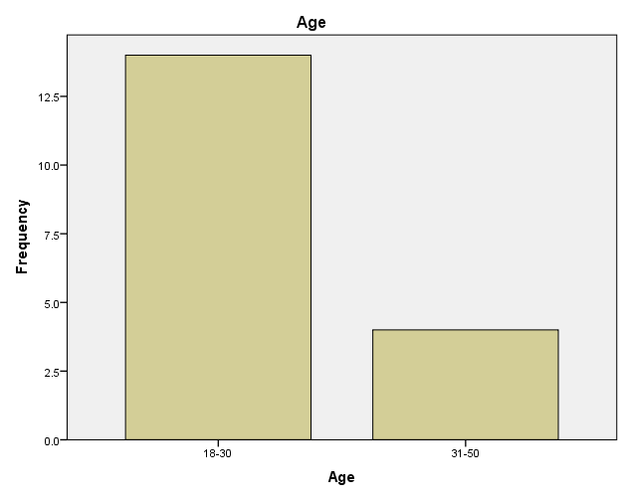

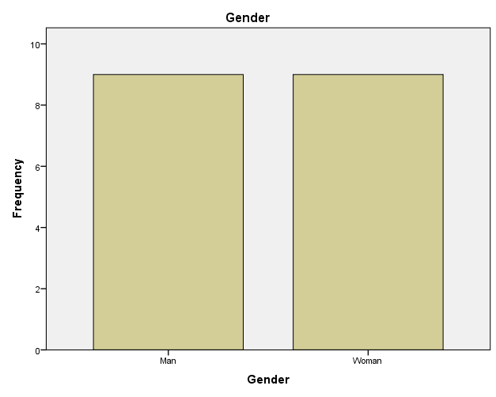

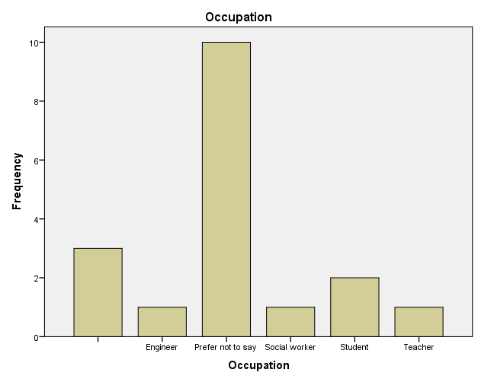

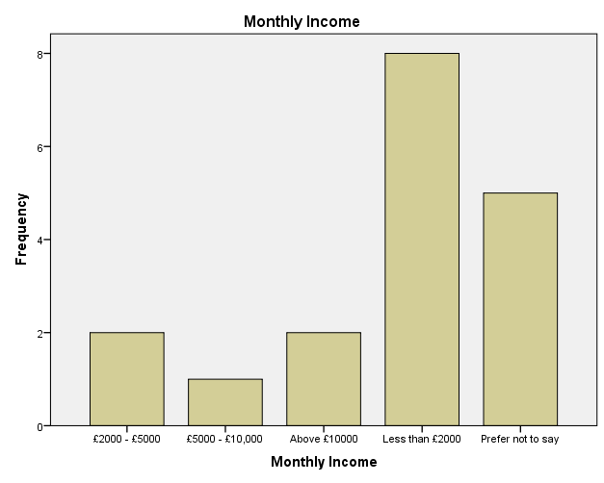

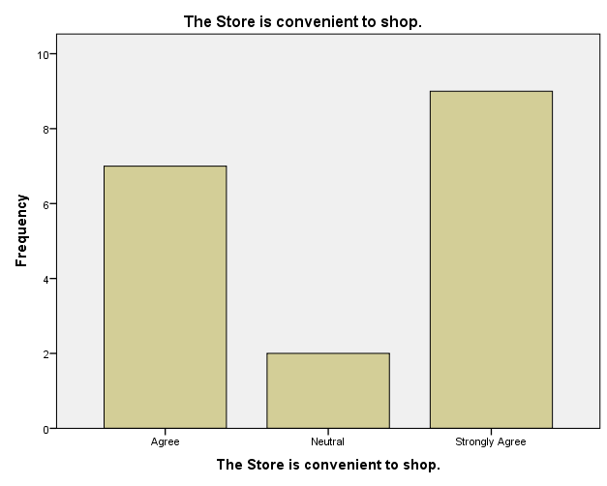

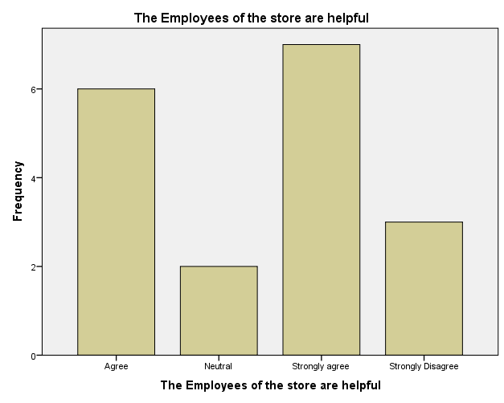

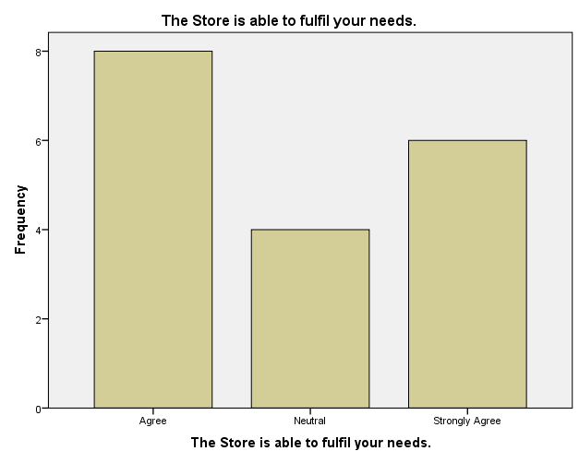

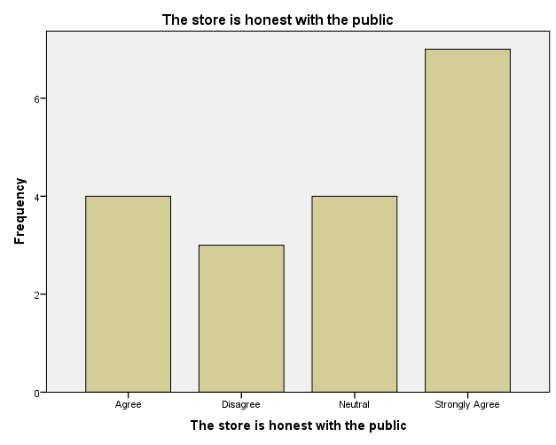

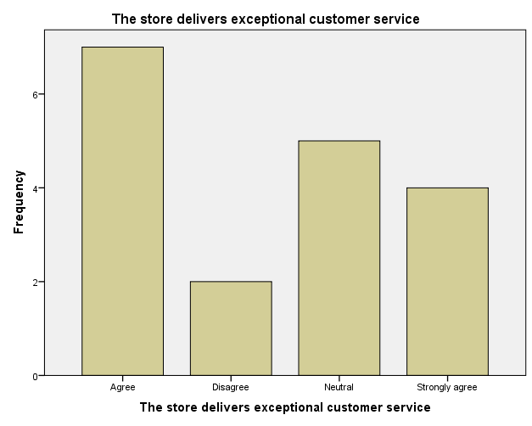

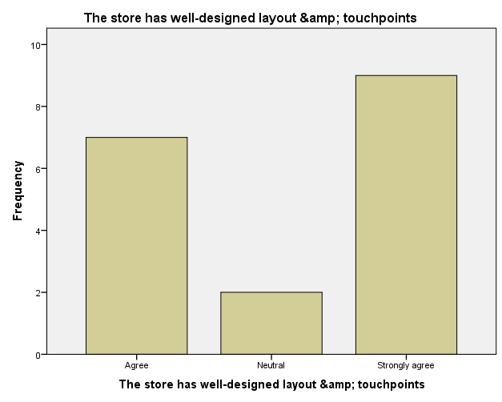

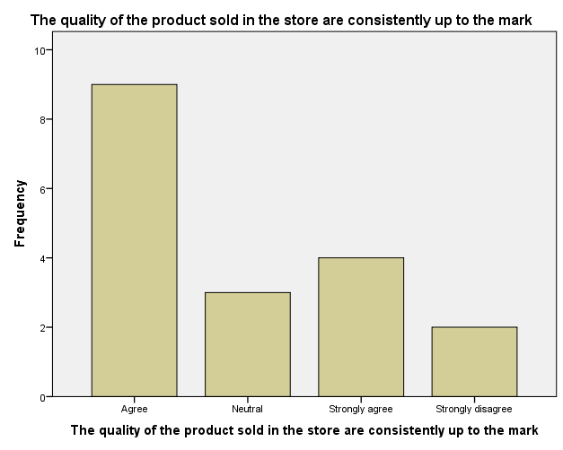

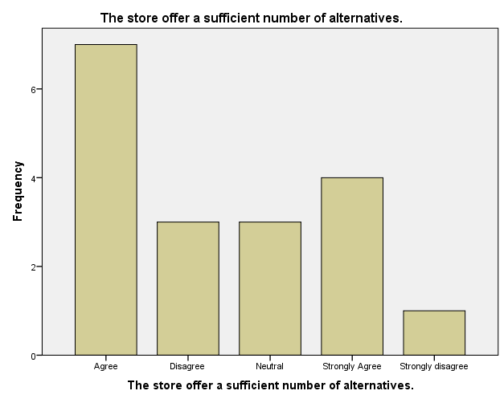

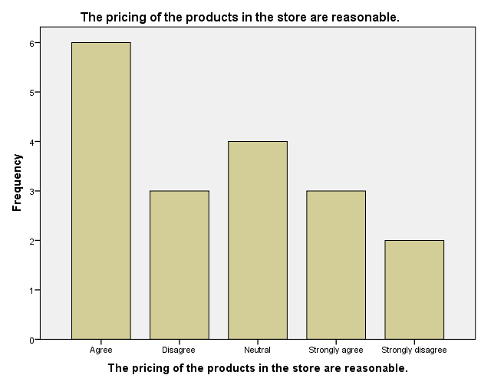

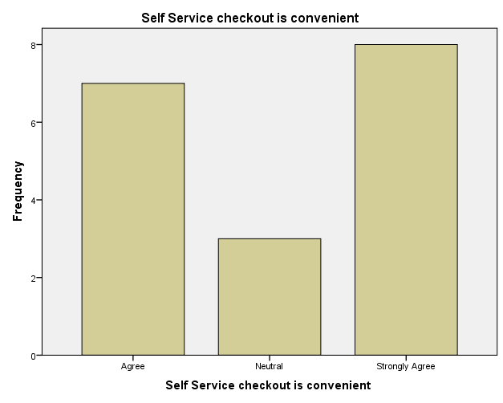

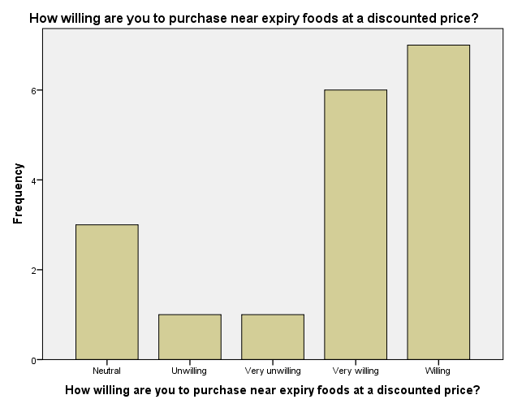

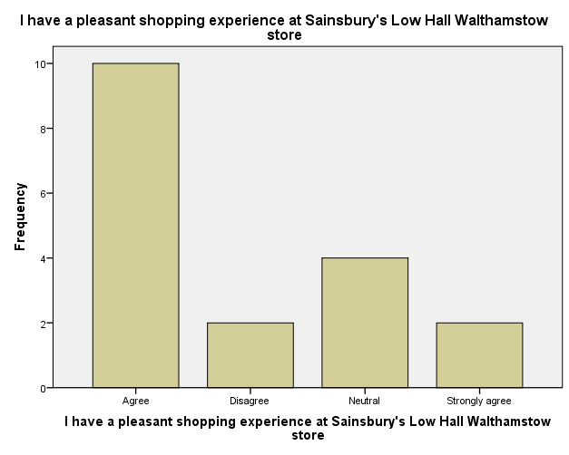

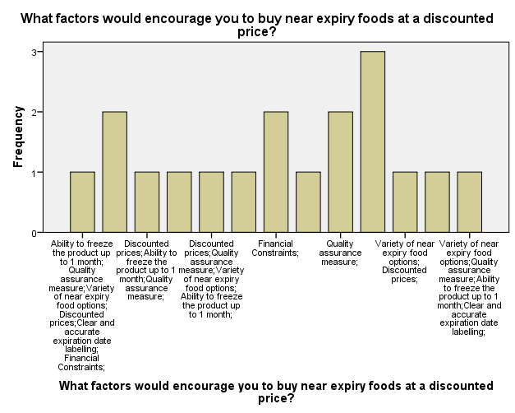

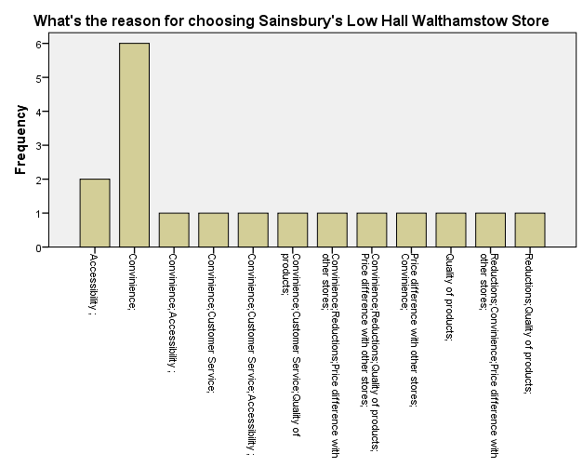

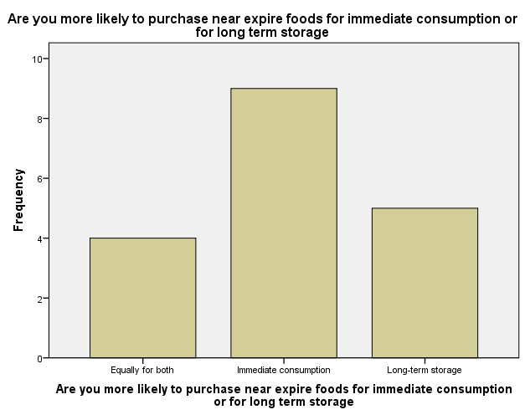

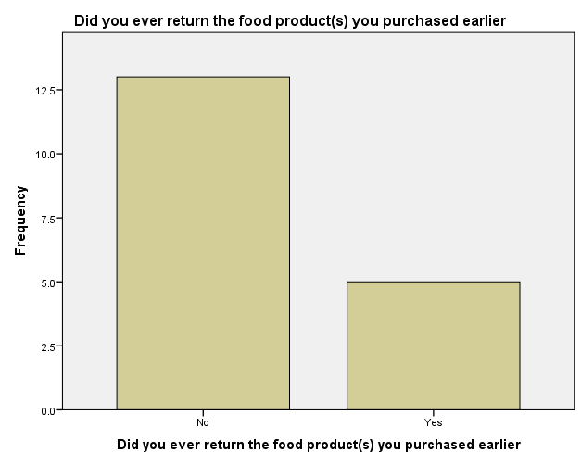

## Chi Square Analysis

(Referred to Appendix 2)

**3.8 Ethical Considerations:**

Ethical norms and guidelines were strictly followed throughout survey administration at the Sainsbury's Low Hall Walthamstow location. Prior to delivering the survey, informed consent was acquired from all participants, and they were promised that their comments would be kept private and anonymous. Respondents were assured that they were under no obligation to complete the survey and might leave at any moment.

No unique IDs were acquired from participants, and the information gathered was utilised for research only. In addition, the survey questions were written in such a way as to steer clear of any potentially invasive or sensitive themes, protecting the respondents' privacy and well-being (McDonald, A.D., 2006).

Data protection laws and the ethical guidelines established by the university's research ethics committee were strictly adhered to throughout the course of this study. Participants were assured of the study's openness and honesty thanks to a thorough explanation of the project's goals.

The research was performed with the participants' and the store's best interests in mind, and any possible conflicts of interest were also addressed. The poll results were used solely for research purposes to improve our knowledge of retail trash management and customer service.

In sum, the ethical considerations made throughout the survey process show that care was taken to protect the privacy and safety of respondents while also honouring their right to respect and dignity.

**3.9 Conclusion**

# This dissertation concluded with an examination of how Sainsbury's Low Hall Walthamstow Store handles garbage and how it may better serve its customers. Customers rated the business highly for its friendly staff, convenient location, and attractive interior design (Stubbs, R.J., 2021). The potential for waste reduction measures was demonstrated by customers' willingness to buy items close to expiration at reduced costs. The research highlighted the significance of combining waste management and customer experience to improve long-term viability and financial success. Throughout the study's conduct, ethical issues were at the forefront (Ormerod, R.J., 1996). The results stress the value of involving customers and implementing efficient waste management procedures in retail contexts. These findings can help Sainsbury's and other stores improve their sustainability and customer service.

# Chapter 4: Findings and Results

## 4.1 Customer Satisfaction

When consumers are happy, they are more inclined to buy from and advocate for that business. Insightful information on customer satisfaction and variables affecting attitudes in the context of Sainsbury's Low Hall Walthamstow store were gleaned from data collected from 18 survey participants.

According to the results of the poll, client satisfaction is rather good. Customers were pleased with the store's location and its proximity to their homes (Time code: 9) and with the helpfulness of the employees (Time code: 10). According to the findings, employees' eagerness to help customers is a major factor in maintaining happy patrons (Lever, J., 2010).

Customer 3 (Time code: 11) is only one example of a customer who expressed agreement that the store was able to meet their needs, proving that the establishment is meeting the expectations of its customers. Fourteen minutes later, shopper number four (Time code: 14) echoed the previous shopper's positive impressions of the store's layout and customer service.

Customers really liked price reductions on products that were about to expire. The company benefits from the increased sales and less waste that result from the price cuts. This helps the shop achieve its environmental goals while also increasing client happiness by satisfying their needs for affordability.

Furthermore, customers' pricing perceptions strongly impact their purchasing habits, as seen by the popularity of Sainsbury's superstores despite the fact that they are more expensive than smaller stores. This demonstrates the potential influence that management pricing and cost management decisions may have on customer satisfaction and, by extension, purchasing behaviour.

According to the statistics, the success of the Sainsbury's shop in Low Hall Walthamstow may be credited to its excellent placement, helpful employees, and well-organized store design. Excellent service to customers is a direct result of leadership that places a premium on employee growth and inspiration. Customer satisfaction, less waste, and savings may all be achieved by providing promotional prices and discounts on products close to their expiration dates (Filimonau, V., & Gherbin, A., 2017). These results highlight the value of leadership in making Sainsbury's in Low Hall Walthamstow a pleasant place to do one's food shopping.

## 4.2 Product Quality and Pricing

Sainsbury's Low Hall Walthamstow surveyed 18 customers to get insight into the role that product quality and pricing play in shaping consumer attitudes and loyalty.

Customer 1 gave a strong endorsement (Time code: 15) to the idea that the store always has high-quality goods. That's why it's so important to adhere to strict quality standards in order to keep up with client demands and boost their overall happiness (Kor, Y.Y., 2017). Keeping up a consistent level of quality is crucial to earning the confidence and loyalty of your customer base.

The price ended up being a major selling point. At the 17-minute point, another respondent agreed wholeheartedly that the store's pricing are reasonable, especially when compared to traditional stores. In light of this, it's clear that using competitive pricing is crucial for attracting and retaining customers. Sales and consumer happiness are both significantly impacted by pricing strategies.

Quality products and lucrative pricing strategies can't be achieved without strong leadership. In order to keep product quality and prices low, upper management plays a critical role in all phases of the production process, including sourcing, quality control, and cost management. Leadership has an effect on the entire customer experience in a number of ways, including by encouraging a customer-centric culture and inspiring workers to deliver stellar service (de Visser-Amundson, 2020).

Customers were happy to take advantage of price reductions on perishable goods. Respondent 3 enthusiastically agreed (at the 19-second mark), indicating that they would buy nearly-expired groceries at a discount. This exemplifies how cutting prices benefits both the consumer and the environment by decreasing the likelihood that food would spoil before its expiration date. The store may remain open because of these price reductions.

The results show that product quality and pricing have a substantial impact on consumers' overall satisfaction. Maintaining product quality, establishing price competitiveness, and encouraging a focus on customers all require strong leadership (Hughes and Merton, 1996). consumers like shopping at Sainsbury's supermarkets because of their low prices, demonstrating once again the critical role that pricing strategies have in bringing in and keeping loyal consumers. These findings highlight the significant impact management has had on the quality of products, competitive pricing, and overall customer happiness at the Sainsbury's location in Low Hall Walthamstow.

## 4.3 Near Expiry Foods

The results of these studies provide insight into the minds of Sainsbury's Low Hall Walthamstow shoppers with regard to the value of giving discounts on foods close to their expiration dates.

Respondent 1 indicated a strong propensity (Time code: 19) to buy near-expiration products at a discount. This result demonstrates the benefits to the business and the customer of offering deep discounts on items that are about to expire. When prices are lowered, more people are able to buy them, especially those who are struggling to make ends meet in today's high cost of living environment.

(Time stamp 20) Another customer mentioned that she'd rather buy food that's about to expire if it's on sale or can be frozen. This choice highlights the need to provide a wide variety of items that are about to expire and to mark them accurately and transparently as such. Improving sales of products close to their expiration dates requires reassuring buyers about their quality and safety (Yang, Y., 2023).

Dealing with products that are about to expire requires strong leadership. In order to demonstrate the company's dedication to ethical and ecologically friendly practises, strong leadership may promote food waste reduction programmes and methods like giving discounts on practically expired commodities. Leadership also encourages a culture of invention and creativity, which may lead to new uses being found for products that are getting near to their expiration dates.

According to the numbers, stores may save money by advertising deals on food that is about to expire. The store's bottom line and the environment both gain from the sale of these things at a discount (Mann, R., Adebanjo, O., & Kehoe, D. 1998).

The fact that Sainsbury's superstores have surpassed small shops in popularity is more evidence that consumers value low costs. In order to guarantee that products that are getting close to their expiry dates are priced competitively, providing value to customers, and cutting down on waste, it is necessary to make smart pricing decisions and manage costs.

Positive consumer attitudes towards near-expiration foods are revealed in the results, highlighting the value of offering discounts on these items. In order to effectively manage perishable food stockpiles, promote sustainability, and implement steps to prevent food waste, good leadership is essential (Sirotina, E., 2016). The store may achieve both its environmental and financial aims by selling products on the verge of expiry. The success of Sainsbury's supermarkets in attracting and maintaining consumers is a testament to the power of price tactics. These results provide supermarket managers with more data with which to make judgements about the disposal of perishable goods and their effect on profits.

## 4.4 Reasons for Choosing the Store

The results of the poll, which included responses from 18 people, provide valuable insight into the motivations and choices of Sainsbury's Low Hall Walthamstow consumers. Understanding these aspects can help supermarket managers provide better service to consumers and stay ahead of the competition (Rohwer L. and Topi M. 2019).

One shopper cited low prices as a crucial factor in their decision to purchase at Sainsbury's in Low Hall Walthamstow (Time code: 21). This discovery underlines the importance of the shop's calculated use of discounting strategies. Attracting clients and obtaining a competitive edge in the market are dependent on the price decisions made by leadership.

Customer 2 (Time code: 21) said that the store's convenience was a major factor in her decision to shop there. Low Hall Walthamstow is favoured by Sainsbury's customers since it is centrally located in relation to both residential and commercial areas (Burch, D., 2001). Leaders can satisfy shoppers' demands for ease of access and convenience by positioning stores strategically and delivering outstanding service.

At the 21:04 mark, Customer 3 raised the profile of customer service as an essential business practise. A customer-centric culture in which staff are given the autonomy to deliver outstanding service to customers is only possible with strong leadership. Key leadership measures in providing a high-quality customer service experience include the implementation of training programmes, engagement initiatives, and clear communication channels.

Customer 4 (Time code: 21) had a similar sentiment, saying that sales are a major motivator for them to go shopping. This evidence lends credence to the theory that lower prices will lead to less waste and a higher profit for the shop. Leadership's price selections, which often include discounts and limited-time offers, are a major draw for bargain-hunting clients (Xiao, B., Chen, Q., & Yu, Z., 2021).

Leadership choices matter greatly in crucial areas including store operations, pricing tactics, customer service, and convenience. Effective leadership is demonstrated when these factors are prioritised and optimised to fulfil the needs and preferences of the consumer base.

In sum, the data demonstrates that there are a number of reasons why clients like shopping at Sainsbury's Low Hall Walthamstow location. Food waste may be reduced and revenues increased by strategic pricing, convenient store locations, a customer-centric attitude, and discounts on almost expired foods. Business leaders in supermarkets would do well to learn about these elements and make strategic adjustments based on what they learn (Ytterhus, B., 1998).

## 4.5 Return Policy and Shopping Experience

Sainsbury's Low Hall Walthamstow location's return policy and shopping experience are major factors in determining whether or not a consumer would return to the store. Eighteen consumers' responses to a survey on the store's return policy and shopping experiences are analysed. Management may use these results to better serve customers and push the company forwards (Naser, K., 1999).

Customer 1's admission that they had returned food goods in the past (Time code: 24) demonstrates the value of a hassle-free return policy. Formulating and conveying return policies that are focused on the consumer requires strong leadership.

The second customer's satisfaction with the return procedure (Time stamp 25) demonstrates that careful consideration was given by management while designing the process (PICIU, P.G.C., 2010). A company's leadership plays a critical role in facilitating the return process and making consumers feel appreciated and cared for from start to finish.

Customer 3 commented that they had a good day shopping at Sainsbury's in Low Hall Walthamstow (day stamp: 26). These results highlight the value of good management in establishing a pleasant retail setting. Decisions made by store management in regards to store layout, upkeep, customer service, and employee training all have an impact on the quality of the customer's experience (Clarke, I., 2012).

The fact that Customer 4 had a good time in the store (Time stamp: 26) is further proof that the management is doing a good job. The store's success is due in part to the management's efforts to increase employee enthusiasm, knowledge, and agency.

As a leader, you should always be looking for ways to improve the return policy and the quality of service you provide to your customers (Urquhart, R., 2022). It is critical to provide regular training for personnel in customer-focused return procedures. Well-designed stores, attentive employees, and happy customers all result from deliberate managerial decisions.

The results of this poll stress the value of offering a hassle-free return policy and providing a pleasant shopping environment in creating delighted and loyal consumers. Designing and explaining clear return policies, training staff for timely returns handling, and establishing a friendly store atmosphere all require the guidance of a strong leader (Aylagas, E., 2020). Strategic leadership efforts, such as marking down perishable goods, may also help the shop save money and cut down on waste. Sainsbury's competitive price advantage over rival local firms exemplifies the significance of sound managerial judgement in preserving a market advantage. Supermarket managers may increase customer loyalty and sales by prioritising customer input and addressing complaints related to the return policy and shopping experience.

## 4.6 Employee Engagement and Customer Interactions

Employees' levels of dedication to their jobs have a direct bearing on the kind of care they can deliver to their clients. A company's ability to connect with its consumers, keep those customers happy, and keep them as loyal customers is directly tied to the level of passion its employees exhibit towards their work.

Sainsbury's Low Hall Walthamstow researchers found that employees' high levels of engagement with their employment resulted in happier interactions with customers. Participants stressed the importance of knowledgeable and friendly staff in fostering a pleasant shopping experience. Employees that go out of their way to assist customers, provide them accurate product information, and respond to their enquiries or concerns are appreciated (Jinglu, W., 2009).

Good leadership has been related to high employee engagement and satisfied consumers. Leadership that promotes employee autonomy and engagement is seen as very valuable by respondents. When workers have confidence in their leaders, they have more pride in their work, and they are more motivated to connect positively with customers.

It was also agreed that investing in employee training and development was critical to developing positive relationships with customers. Members of the focus group emphasised the importance of employees possessing in-depth product knowledge and the capacity to solve problems. According to Cooper (2003), subpar customer service results when employees aren't given the tools they need to succeed in a variety of customer service roles.

Employees' enthusiasm in their work has a significant effect on the quality of service they provide to consumers. Strong leadership, personnel development initiatives, and training opportunities may all contribute to improved customer interactions and a more satisfying shopping experience. Focusing on employee engagement and investing in their training and development may help businesses increase customer satisfaction and loyalty, which in turn improves economic performance (Hutcheson, G.D., & Moutinho, L. (1998).

# Chapter 5: Conclusion and Discussion

These findings and interpretations were compiled at the request of Sainsbury's Low Hall Walthamstow. The studies' principal focuses were on employee motivation and customer service. This section will provide a high-level overview of the study's results and discuss their relevance to the retail industry.

The study's goal was to learn how customers interact with the company and its workers in a variety of contexts, such as those involving employee engagement, product quality and price, perishable food, store choice, return policy, and the overall shopping experience. Customers' tastes and routines were studied so that new approaches might be devised to increase customer satisfaction and broaden the business's market (Antasouras, G., 2023) success.

Here, we'll take a high-level look at the study's findings and summarise the main takeaways by discussing the recurrent themes that surfaced during the examination. Implications for leadership, customer involvement, and service quality are explored after a thorough analysis of the findings. The article offers ideas for how Sainsbury's Low Hall Walthamstow might improve its operations and maintain its competitive advantage, as well as discusses the implications for the retail industry as a whole.

## 5.1 Summary of Findings

The study's findings shed light on several facets of the Sainsbury's Low Hall Walthamstow customer experience and satisfaction. Positive interactions with customers were found to be significantly influenced by employee engagement. Customers valued enthusiastic and accommodating workers, highlighting the significance of a well-informed and hospitable team in producing a satisfying shopping experience. Furthermore, it was shown that product quality and affordability were significant decision factors for customers. Customers wanted reliable quality at reasonable pricing (Townsend, R.E., 2019), underscoring the importance of value for money.

Customers were pleased to find items close to expiration available at reduced costs, as this gave them the choice to save money and eat them right away or store them in the freezer. The business was picked because of its competitive prices, convenient location, helpful staff, and high-quality goods. Last but not least, happy customers were the result of a no-hassle return policy, an inviting store layout, and a convenient self-checkout.

Sainsbury's Low Hall Walthamstow may use these results to improve their customers' shopping experiences, their connections with the store, and their bottom line. Creating a great image among consumers and encouraging customer loyalty requires a strong focus on staff involvement, product quality and competitive price, giving reduced near expiration foods, and a pleasant shopping atmosphere. It is impossible to overestimate the importance of leadership in encouraging staff participation and developing a customer-focused culture (Mech, T., and Young, M.D., 2001). Implementing price cuts on commodities that are close to expiration helps customers save money and aids sustainability initiatives by decreasing food waste.

In sum, these results provide valuable insight for Sainsbury's Low Hall Walthamstow's strategic decision making and shine a light on opportunities to further enhance the shopping experience for the store's regulars.

## 5.2 Employee Engagement and Customer Interactions

The study's results highlight the significance of staff involvement in influencing the quality of customer service provided by Sainsbury's Low Hall Walthamstow. Customers gave high marks to businesses whose staff members went out of their way to be helpful, knowledgeable, and kind. Their kind demeanour and eagerness to help made clients feel welcome and ensured their contentment. In order to better serve customers and create an environment where they feel valued, it is crucial to engage in training and development programmes for staff (Bennett, M., 2001).

Regular communication, appreciation, and empowerment are all examples of effective employee engagement tactics that help build a dedicated and enthusiastic team. Employees that have a strong sense of belonging to their organisation are more invested in going above and beyond for their customers. Improving relationships with customers is only one side effect of fostering a healthy work environment that promotes cooperation and teamwork.

The results highlight the importance of staff involvement in maintaining loyal customers. Customers who leave a business feeling satisfied are more likely to return and tell others about their experience. Therefore, investing in staff engagement initiatives not only improves relationships with customers, but also helps the company succeed in the long run.

Employee involvement and a focus on the customer are two outcomes that can benefit greatly from strong leadership (Sheppard, M., 1993). Inspiring staff to provide outstanding customer service may be accomplished via the use of effective leadership practises such as defining clear objectives, offering frequent feedback, and leading by example. Furthermore, leaders should facilitate learning and growth for their teams so that employees may grow into their positions and contribute significantly to interactions with customers.

Positive encounters with customers are a direct result of the level of employee engagement at Sainsbury's Low Hall Walthamstow, as shown by the study's findings. Increased customer loyalty and commercial success may be achieved by the store's dedication to staff engagement activities and the development of a customer-centric culture (Abdel-Kader, M., and Luther, R. (2008).

## 5.3 Product Quality and Pricing

Product quality and price were shown to be significant factors affecting customers' opinions of the store and their decisions to make purchases at Sainsbury's Low Hall Walthamstow. The store's success can be attributed to the continuously high quality of the things it sells. Customers are more satisfied and loyal to a brand when their expectations for the product's freshness, flavour, and overall quality are met or exceeded. The results stress the need for strict quality control methods to be in place to guarantee that goods always match expectations.

Customers' views were also shown to be significantly affected by pricing. Customers are more likely to make a purchase when they feel they are getting a good deal. They anticipate reasonable costs that are in keeping with their budgets and provide a good value for the things they purchase. The study's findings highlight the need of sustaining profitability while being competitive for Sainsbury's Low Hall Walthamstow (Mägi, A.W., 2003).

Consumers are prepared to spend more for things they perceive to be of higher quality, according to the research, but exorbitant prices may prevent them from making a purchase. In order to make sure their pricing plans are in line with customer expectations and market conditions, stores need to continually monitor market trends and rivals' pricing.

According to research by Lindgreen and Swaen (2005), leaders have a significant influence in ensuring that product quality and pricing meet or exceed consumer expectations. Maintaining customer satisfaction and competitive pricing strategies requires effective leadership practises include monitoring quality control procedures, doing frequent market research, and making price decisions based on data.

The study's results show that product quality and cost are two of the most influential factors on customers' opinions and actions. Customer happiness, loyalty, and the company's bottom line may all be boosted by Sainsbury's Low Hall Walthamstow's implementation of price-cutting methods and a commitment to maintaining high product quality standards.

## 5.4 Near Expiry Foods

The results of this study provide insight into how shoppers at Sainsbury's Low Hall Walthamstow feel about products close to their expiration dates. Customers' willingness to buy items close to expiration at reduced pricing hints to the category's potential to cut down on food waste and bring in more cash for the grocery store. Discounted costs, a wide selection of near-expiration food alternatives, and quality assurance methods were found to be significant influences in customers' decisions to purchase these items (Eccles, R.G., 2015).

Customers recognised that financial considerations typically play a role in their purchase decisions, making deeply discounted meals close to expiration an appealing alternative. Customers were more likely to buy perishable items close to their expiration dates if they knew they could freeze them for later use.

Leadership is critical to the success of solutions for dealing with food that is about to go bad. For this reason, it is important to set up transparent quality evaluation processes, use up-to-date expiration date labelling, and practise effective inventory management (Jones, P., 2001).

The results of this study show that there may be an advantage to selling food that is about to expire at a reduced price. Sainsbury's Low Hall Walthamstow can better satisfy the needs and preferences of its consumers and decrease waste in this area by managing and advertising this category of items. The results highlight the need for effective leadership to implement suitable strategies and practises to increase the marketability and longevity of perishable items that are close to their expiration dates without compromising food safety.

## 5.5 Reasons for Choosing the Store

The results of the study provide insight into why Sainsbury's in Low Hall Walthamstow is so popular with locals. Differential pricing from competitors, customer service, product quality, ease of access, and discounts were all regarded as influential by participants (Dangana, Z, 2012).

A major issue was found to be the price differential between Sainsbury's Low Hall Walthamstow and the competition in the area. People also highlighted how easy it was to go to the store from where they lived. Customers were pleased with the service they received from the store's staff, who were praised for being kind and helpful.

Results show that customers are most influenced by price, location, ease of shopping, and quality of service at Sainsbury's Low Hall Walthamstow (Stelzenmüller, V., 2021). Customers' levels of pleasure, loyalty, and general preference for a shop can all benefit from a deeper understanding of and attention to these issues. Maintaining customer satisfaction and staying ahead of the competition requires smart thinking and strong leadership.

## 5.6 Return Policy and Shopping Experience

Participants' responses were analysed to reveal important information on returns and the overall shopping experience at Sainsbury's in Low Hall, Walthamstow. According to the results, the return policy has been helpful to a large number of clients. Many respondents echoed the positive sentiment that the return procedure was simple and straightforward.

The majority of respondents had a favourable impression of the store as a whole and their shopping experience there. Many customers commented on how much they like the store's atmosphere, stating their agreement or strong agreement that shopping there was a nice experience. The store's efforts to keep its layout and points of contact well-designed were also noticed and appreciated (Newbury, B., 2000).

These results imply that Sainsbury's in Low Hall Walthamstow has achieved its goal of providing its consumers with a satisfying shopping experience. Customers are happy and loyal because of the store's easy return policy and nice atmosphere.

Customers are drawn to and kept by the business in large part because of its convenient return policy and pleasant shopping environment (Argyropoulou, M., 2023). Keeping up with client demands necessitates constant attention to these details. The store's profitability and competitive advantage rely heavily on the leadership of its customer service representatives.

## 5.7 Discussion and Implications

The study's assessment of its results on many areas of Sainsbury's Low Hall Walthamstow sheds light on how its customers feel about the store. The results of this study have important ramifications for the way the shop is run and the decisions made moving forwards.

Firstly, encouraging a motivated and customer-oriented staff is crucial (Smith, A.D.M., 1999) as seen by the positive comments on employee engagement and interactions with customers. Engaged workers who go above and beyond to help customers are rewarded with happier customers who are more likely to make repeat purchases. To further improve interactions with customers and overall happiness, it is important to engage in staff training and development programmes, recognise and reward great performance, and cultivate a supportive work environment.

Second, buyers place a high value on product quality and affordability, as seen by the correlation between these two aspects and their purchase decisions. Maintaining a loyal client base requires maintaining a stable product quality and offering reasonable prices (Jory, S.R., 2019). Maintaining a loyal client base requires constant quality assurance tests, dependable supplier partnerships, and affordable pricing.

The findings highlight the significance of criteria like price, convenience, customer service, and product quality as explanations for shopping there. The shop's competitive position and customer base can both benefit from a deeper understanding of these characteristics and a more concerted effort to tailor store tactics to match client preferences.

## 5.8 Wrapping Up

Sainsbury's Low Hall Walthamstow store's study on numerous elements has yielded useful insights into customers' views, preferences, and experiences. Employee enthusiasm, product quality, price, perishables, and customer motivation have all been illuminated by the research. These results have major ramifications for the business's current practises and future plans.

First, it's clear from the literature that both staff involvement and customer contacts significantly impact the quality of the customer service provided (Bettley, A., & Burnley, S., 2008). The importance of maintaining a motivated and customer-oriented staff is shown by the good comments customers have made about the helpfulness of personnel and their ability to satisfy their demands. Further improving customer interactions and happiness may be accomplished by the store's investment in employee training, the establishment of a good work environment, and the recognition of excellent performance (Canning, L., 2006).

Second, shoppers have shown to place a premium on product quality and affordability. In order to attract and keep clients in a highly competitive market, it is crucial to offer both stable product quality and reasonable prices (Foxall, G.R., 2006). Meeting client expectations and gaining their trust may be accomplished through consistent quality inspections, dependable supplier selection, and competitive pricing.

The results concerning items close to their expiration dates indicate a chance for the store to cut down on food wastage and increase profits (Hopkins, J., 2011). Customers can be encouraged to buy food that is about to expire by providing discounts, expanding selections, and providing clear communication about expiration dates.

# References

Abdel-Kader, M. and Luther, R., 2008. The impact of firm characteristics on management accounting practices: A UK-based empirical analysis. *The British Accounting Review*, *40*(1), pp.2-27

Ali, B.J.,, Saleh, P.F.,, Akoi, S.,, Abdulrahman, A.A.,, Muhamed, A.S.,, Noori, H.N., and Anwar, G., 2021. Impact of service quality on the customer satisfaction: Case study at online meeting platforms. International Journal of Engineering, Business and Management, 5(2), pp.65–77.

Kirby, A., 2008. The architectural design of UK supermarkets 1950-2006 (Doctoral dissertation, University of the Arts London).

Jackson, A.A., 2018. Semi-detached London: suburban development, life and transport, 1900-39 (Vol. 2). Routledge.

Pearson, D., 2013. The 20 Ps of marketing: A complete guide to marketing strategy. Kogan Page Publishers.

Toynbee, P. and Walker, D., 2015. Cameron's Coup: How the Tories took Britain to the brink. Guardian Faber Publishing.

Lever, J., Puig della Bellacasa, M., Miele, M. and Higgin, M., 2010. From the slaughterhouse to the consumer: transparency and information in the distribution of Halal and Kosher meat.

Antasouras, G., Vasios, G.K., Kontogiorgis, C., Ioannou, Z., Poulios, E., Deligiannidou, G.E., Troumbis, A.Y. and Giaginis, C., 2023. How to improve food waste management in hospitals through focussing on the four most common measures for reducing plate waste. *The International Journal of Health Planning and Management*, *38*(2), pp.296-316.

Argyropoulou, M., Zissis, D., Korfiatis, N. and Zampou, E., 2023. Horizontal collaboration in the last mile distribution: gauging managerial response to disruption and abnormal demand. *Benchmarking: An International Journal*, *30*(2), pp.460-474.

Aylagas, E., Borja, A., Pochon, X., Zaiko, A., Keeley, N., Bruce, K., Hong, P., Ruiz, G.M., Stein, E.D., Theroux, S. and Geraldi, N., 2020. Translational molecular ecology in practice: linking DNA-based methods to actionable marine environmental management. *Science of the Total Environment*, *744*, p.140780.

Bennett, M., James, P. and Bartolemeo, M., 2001. *Eco-management accounting: guidelines for accountants, business advisers and environmental managers*. BSI British Standards Institution.

Bettley, A. and Burnley, S., 2008. Towards sustainable operations management integrating sustainability management into operations management strategies and practices. *Handbook of performability engineering*, pp.875-904.

Mehta, N., Cunningham, E., Doherty, M., Sainsbury, P., Bolaji, I., Firoozi-Nejad, B. and Smyth, B.M., 2022. Using regional material flow analysis and geospatial mapping to support the transition to a circular economy for plastics. Resources, Conservation and Recycling, 179, p.106085.

Fearne, A., Barrow, S. and Schulenberg, D., 2006. Implanting the benefits of buyer‐supplier collaboration in the soft fruit sector. Supply Chain Management: An International Journal, 11(1), pp.3-5.

de Visser-Amundson, A. and Kleijnen, M., 2020. Nudging in food waste management: Where sustainability meets cost-effectiveness. Food waste management: Solving the wicked problem, pp.57-87.

Keiningham, T., Aksoy, L., Bruce, H.L., Cadet, F., Clennell, N., Hodgkinson, I.R. and Kearney, T., 2020. Customer experience driven business model innovation. Journal of Business Research, 116, pp.431-440.

Gislason, H., Sinclair, M., Sainsbury, K. and O'boyle, R., 2000. Symposium overview: incorporating ecosystem objectives within fisheries management. ICES Journal of Marine Science, 57(3), pp.468-475.

Hughes, D. and Merton, I., 1996. “Partnership in produce”: the J Sainsbury approach to managing the fresh produce supply chain. Supply Chain Management: an international journal, 1(2), pp.4-6.

Styles, D., Schoenberger, H. and Galvez-Martos, J.L., 2012. Environmental improvement of product supply chains: Proposed best practice techniques, quantitative indicators and benchmarks of excellence for retailers. Journal of Environmental Management, 110, pp.135-150.

Alexander, C. and Smaje, C., 2008. Surplus retail food redistribution: An analysis of a third sector model. Resources, conservation and recycling, 52(11), pp.1290-1298.

Watkinson, M., 2013. The ten principles behind great customer experiences. Pearson UK.

Ytterhus, B.E., Arnestad, P. and Lothe, S., 1999. Environmental initiatives in the retailing sector: an analysis of supply chain pressures and partnerships. Eco‐Management and Auditing: The Journal of Corporate Environmental Management, 6(4), pp.181-188.

De Keyser, A., Verleye, K., Lemon, K.N., Keiningham, T.L. and Klaus, P., 2020. Moving the customer experience field forward: introducing the touchpoints, context, qualities (TCQ) nomenclature. Journal of Service Research, 23(4), pp.433-455. [Online} Available at: <https://journals.sagepub.com/doi/abs/10.1177/1094670520928390> (Accessed 1st August, 2023)

Gil-Gomez, H., Guerola-Navarro, V., Oltra-Badenes, R. and Lozano-Quilis, J.A., 2020. Customer relationship management: digital transformation and sustainable business model innovation. Economic research-Ekonomska istraživanja, 33(1), pp.2733-2750. [Online} Available at: <https://www.tandfonline.com/doi/abs/10.1080/1331677X.2019.1676283> (Accessed 1st August, 2023)

Keiningham, T., Aksoy, L., Bruce, H.L., Cadet, F., Clennell, N., Hodgkinson, I.R. and Kearney, T., 2020. Customer experience driven business model innovation. Journal of Business Research, 116, pp.431-440. [Online} Available at: <https://www.sciencedirect.com/science/article/pii/S014829631930462X> (Accessed 1st August, 2023)

Parajuly, K., Fitzpatrick, C., Muldoon, O. and Kuehr, R., 2020. Behavioral change for the circular economy: A review with focus on electronic waste management in the EU. Resources, Conservation & Recycling: X, 6, p.100035. [Online} Available at: <https://www.sciencedirect.com/science/article/pii/S2590289X20300062> (Accessed 1st August, 2023)

Salmenperä, H., Pitkänen, K., Kautto, P. and Saikku, L., 2021. Critical factors for enhancing the circular economy in waste management. Journal of cleaner production, 280, p.124339. [Online} Available at: <https://www.sciencedirect.com/science/article/pii/S0959652620343845> (Accessed 1st August, 2023)

Vanapalli, K.R., Sharma, H.B., Ranjan, V.P., Samal, B., Bhattacharya, J., Dubey, B.K. and Goel, S., 2021. Challenges and strategies for effective plastic waste management during and post COVID-19 pandemic. Science of The Total Environment, 750, p.141514. [Online} Available at: <https://www.sciencedirect.com/science/article/pii/S0048969720350439> (Accessed 1st August, 2023)

Jones, P., Clarke‐Hill, C., Comfort, D., Hillier, D. and Shears, P., 2005. Radio frequency identification and food retailing in the UK. British Food Journal, 107(6), pp.356-360.

Hall, J., 2000. Environmental supply chain dynamics. Journal of cleaner production, 8(6), pp.455-471.

Chkanikova, O. and Mont, O., 2015. Corporate supply chain responsibility: drivers and barriers for sustainable food retailing. Corporate Social Responsibility and Environmental Management, 22(2), pp.65-82.

Yang, Y., Barnes, H., Yang, B., Onofrei, G. and Nguyen, H., 2023. Food waste management for the UK grocery retail sector—a supply chain collaboration perspective. Production Planning & Control, pp.1-14.

Tong, A., Sainsbury, P., Chadban, S., Walker, R.G., Harris, D.C., Carter, S.M., Hall, B., Hawley, C. and Craig, J.C., 2009. Patients' experiences and perspectives of living with CKD. American Journal of Kidney Diseases, 53(4), pp.689-700.

Furseth, P.I. and Cuthbertson, R., 2013. The service innovation triangle: a tool for exploring value creation through service innovation. International Journal of Technology Marketing 24, 8(2), pp.159-176.

Haddock‐Fraser, J., 2012. The role of the news media in influencing corporate environmental sustainable development: an alternative methodology to assess stakeholder engagement. Corporate Social Responsibility and Environmental Management, 19(6), pp.327-342.

Huang, I.Y., Manning, L., James, K.L., Grigoriadis, V., Millington, A., Wood, V. and Ward, S., 2021. Food waste management: A review of retailers’ business practices and their implications for sustainable value. Journal of Cleaner Production, 285, p.125484.

Sullivan, R. and Gouldson, A., 2016. Comparing the climate change actions, targets and performance of UK and US retailers. Corporate Social Responsibility and Environmental Management, 23(3), pp.129-139.

Sainsbury, P., Charlesworth, K., Madden, L., Capon, A., Stewart, G. and Pencheon, D., 2019. Climate change is a health issue: what can doctors do?. Internal Medicine Journal, 49(8), pp.1044-1048.

Hill, N., Roche, G. and Allen, R., 2007. Customer satisfaction: the customer experience through the customer's eyes. The Leadership Factor.

Tong, A., Sainsbury, P., Carter, S.M., Hall, B., Harris, D.C., Walker, R.G., Hawley, C.M., Chadban, S. and Craig, J.C., 2008. Patients’ priorities for health research: focus group study of patients with chronic kidney disease. Nephrology Dialysis Transplantation, 23(10), pp.3206-3214.

Zhou, S., Smith, A.D., Punt, A.E., Richardson, A.J., Gibbs, M., Fulton, E.A., Pascoe, S., Bulman, C., Bayliss, P. and Sainsbury, K., 2010. Ecosystem-based fisheries management requires a change to the selective fishing philosophy. Proceedings of the National Academy of Sciences, 107(21), pp.9485-9489.

Gutierrez, N.L., Valencia, S.R., Branch, T.A., Agnew, D.J., Baum, J.K., Bianchi, P.L., Cornejo-Donoso, J., Costello, C., Defeo, O., Essington, T.E. and Hilborn, R., 2012. Eco-label conveys reliable information on fish stock health to seafood consumers.

Spence, L.J. and Rinaldi, L., 2010. Sainsbury’s: Embedding sustainability within the supermarket supply chain. Accounting for Sustainability: Practical Insights, Earthscan, pp.47-71.

Barry, M.T., 2011. Life cycle assessment and the New Zealand wine industry: a tool to support continuous environmental improvement: a thesis presented in partial fulfilment of the requirements for the degree of Master of Environmental Management in Life Cycle Management at Massey University, Wellington, New Zealand (Doctoral dissertation, Massey University).

Kirkup, M., De Kervenoael, R., Hallsworth, A., Clarke, I., Jackson, P. and Perez del Aguila, R., 2004. Inequalities in retail choice: exploring consumer experiences in suburban neighbourhoods. International Journal of Retail & Distribution Management, 32(11), pp.511-522.

Amano, T., Berdejo-Espinola, V., Christie, A.P., Willott, K., Akasaka, M., Báldi, A., Berthinussen, A., Bertolino, S., Bladon, A.J., Chen, M. and Choi, C.Y., 2021. Tapping into non-English-language science for the conservation of global biodiversity. PLoS Biology, 19(10), p.e3001296.

Jones, P., Comfort, D., Hillier, D. and Eastwood, I., 2005. Corporate social responsibility: a case study of the UK's leading food retailers. British Food Journal, 107(6), pp.423-435.

Cole, C., Gnanapragasam, A., Cooper, T. and Singh, J., 2019. An assessment of achievements of the WEEE Directive in promoting movement up the waste hierarchy: experiences in the UK. Waste Management, 87, pp.417-427.

Palmer, S.C., Gray, H., Huria, T., Lacey, C., Beckert, L. and Pitama, S.G., 2019. Reported Māori consumer experiences of health systems and programs in qualitative research: a systematic review with meta-synthesis. International journal for equity in health, 18(1), pp.1-12.

Caritte, V., Acha, S. and Shah, N., 2015. Enhancing corporate environmental performance through reporting and roadmaps. Business Strategy and the Environment, 24(5), pp.289-308.

McDonald, A.D., Fulton, E., Little, L.R., Gray, R., Sainsbury, K.J. and Lyne, V.D., 2006. Multiple-use management strategy evaluation for coastal marine ecosystems using InVitro. Complex science for a complex world, p.283.

Stubbs, R.J., Duarte, C., Palmeira, A.L., Sniehotta, F.F., Horgan, G., Larsen, S.C., Marques, M.M., Evans, E.H., Ermes, M., Harjumaa, M. and Turicchi, J., 2021. Evidence-Based digital tools for weight loss maintenance: the nohow project. Obesity Facts, 14(3), pp.320-333.

Ormerod R.J., 1996. Information systems strategy development at Sainsbury's supermarkets using “soft” OR. Interfaces, 26(1), pp.102-130.

Burch, D., Lyons, K. and Lawrence, G., 2001. What do we mean by ‘green’? Consumers, agriculture and the food industry. *Consuming foods, sustaining environments*, pp.33-46.

Burton, J.,, Gruber, T., and Gustafsson, A., 2021. Fostering collaborative research for customer experience –connecting academic and practitioner worlds. Journal of Business Research, 130, pp.736–740.

Canning, L., 2006. Rethinking market connections: mobile phone recovery, reuse and recycling in the UK. *Journal of Business & Industrial Marketing*, *21*(5), pp.320-329.

Clarke, I., Kirkup, M. and Oppewal, H., 2012. Consumer satisfaction with local retail diversity in the UK: effects of supermarket access, brand variety, and social deprivation. *Environment and Planning A*, *44*(8), pp.1896-1911.

Coopey, J., 2003. Sustainable development and environmental management: The performance of UK business schools. *Management Learning*, *34*(1), pp.5-26.

Dangana, Z., Pan, W. and Goodhew, S., 2012. Delivering sustainable buildings in retail construction. In *Annual Association of Researchers in Construction Management (ARCOM) Conference Proceedings*. Association of Researchers in Construction Management (ARCOM)..

de Visser-Amundson, A. and Kleijnen, M., 2020. Nudging in food waste management: Where sustainability meets cost-effectiveness. *Food waste management: Solving the wicked problem*, pp.57-87.

Dawadi, S.,, Shrestha, S., and Giri, R.A., 2021. Mixed-methods research: A discussion on its types, challenges, and criticisms. Journal of Practical Studies in Education, 2(2), pp.25–36.

Eccles, R.G., Krzus, M.P. and Ribot, S., 2015. Models of best practice in integrated reporting 2015. *Journal of Applied Corporate Finance*, *27*(2), pp.103-115.

Efstratiadi, M.,, Acha, S.,, Shah, N., and Markides, C.N., 2019. Analysis of a closed-loop water-cooled refrigeration system in the Food Retail Industry: A UK case study. Energy, 174, pp.1133–1144.

Filimonau, V. and Gherbin, A., 2017. An exploratory study of food waste management practices in the UK grocery retail sector. *Journal of Cleaner Production*, *167*, pp.1184-1194.

Foxall, G.R., Oliveira-Castro, J.M., James, V.K., Yani-de-Soriano, M.M. and Sigurdsson, V., 2006. Consumer behavior analysis and social marketing: The case of environmental conservation. *Behavior and social issues*, *15*, pp.101-125.

Hopkins, J., 2011. *Piloting a methodology to understand waste reduction behaviour in Charnwood* (Doctoral dissertation, Loughborough University).

Hughes, D. and Merton, I., 1996. “Partnership in produce”: the J Sainsbury approach to managing the fresh produce supply chain. *Supply Chain Management: an international journal*, *1*(2), pp.4-6.

Hutcheson, G.D. and Moutinho, L., 1998. Measuring preferred store satisfaction using consumer choice criteria as a mediating factor. *Journal of marketing Management*, *14*(7), pp.705-720.

Jinglu, W., 2009. An investigation into practices implications of green supply chain management in the UK retail sector.

Jones, P., and Comfort, D., 2019. A commentary on the United Kingdom’s leading food retailers’ resilience plans in the face of climate change. Journal of Public Affairs, 20(2).

Jory, S.R., Benamraoui, A., Madichie, N.O., Ruiz-Alba, J.L. and Chistodoulou, I., 2019. Are retailers “bagging” the carrier bag levy in England? An exploratory enquiry. *Journal of environmental management*, *233*, pp.845-853.

Kajamaa, A.,, Mattick, K., and Croix, A., 2020. How to … do mixed‐methods research. The Clinical Teacher, 17(3), pp.267–271.

Kor, Y.Y., Prabhu, J. and Esposito, M., 2017. How large food retailers can help solve the food waste crisis. *Harvard business review*, *19*.

Lever, J., Puig della Bellacasa, M., Miele, M. and Higgin, M., 2010. From the slaughterhouse to the consumer: transparency and information in the distribution of Halal and Kosher meat.

Li, X.,, Xu, M.,, Zeng, W.,, Tse, Y.K., and Chan, H.K., 2023. Exploring customer concerns on service quality under the COVID-19 crisis: A Social Media Analytics study from the retail industry. Journal of Retailing and Consumer Services, 70, p.103157.

Lindgreen, A. and Swaen, V., 2005. Corporate citizenship: Let not relationship marketing escape the management toolbox. *Corporate Reputation Review*, *7*, pp.346-363.

Mägi, A.W., 2003. Share of wallet in retailing: the effects of customer satisfaction, loyalty cards and shopper characteristics. *Journal of retailing*, *79*(2), pp.97-106.

Mann, R., Adebanjo, O. and Kehoe, D., 1998. Best practices in the food and drinks industry. *Benchmarking for Quality Management & Technology*, *5*(3), pp.184-199.

Mech, T. and Young, M.D., 2001. Designing voluntary environmental management arrangements to improve natural resource management in agriculture and allied rural industries. *RIRDC Report CSL-15A. RIRDC Publication*, *1*, p.39.

Naser, K., Jamal, A. and Al‐Khatib, K., 1999. Islamic banking: a study of customer satisfaction and preferences in Jordan. *International journal of bank marketing*, *17*(3), pp.135-151.

Naufel, K.Z., and Edwards, V.M., 2022. Ethical considerations of Social Change Research. Ethical Considerations of Social Change Research.

Newbury, B., 2000. *Integrated Health, Safety and Environmental Management Systems*. University of South Wales (United Kingdom).

PICIU, P.G.C., 2010. Environmental management at the microeconomic level. *Financial Studies*, *3*(2010), pp.152-168.

Rohwer, L. and Topić, M.K. (2018) “The communication of Corporate–NGO Partnerships: analysis of Sainsbury’s collaboration with Comic Relief,” Journal of Brand Management, 26(1), pp. 35–48. Available at: <https://doi.org/10.1057/s41262-018-0111-7>.

Sainsbury, S.L., 1995. *EcoCost: an ecological evaluation system for building materials* (Doctoral dissertation, University of Tasmania).

Sainsbury, D.C.G. (1994) “Technology and International Competitiveness 1993 Arthur Andersen Lecture, University of Cambridge,” Business Strategy Review, 5(1), pp. 1–13. Available at: <https://doi.org/10.1111/j.1467-8616.1994.tb00066.x>.

Sheppard, M., 1993. Client satisfaction, extended intervention and interpersonal skills in community mental health. *Journal of Advanced Nursing*, *18*(2), pp.246-259.

Shackleton, R. (1998) “Exploring Corporate Culture and Strategy: Sainsbury at Home and Abroad during the Early to Mid 1990s,” Environment and Planning A [Preprint]. Available at: <https://doi.org/10.1068/a300921>.

Sirotina, E., 2016. Sustainable waste management of perishables in a large retail: case study on Intermarchè, France.

Smith, A.D.M., Sainsbury, K.J. and Stevens, R.A., 1999. Implementing effective fisheries-management systems–management strategy evaluation and the Australian partnership approach. *ICES Journal of Marine Science*, *56*(6), pp.967-979.

Stelzenmüller, V., Cormier, R., Gee, K., Shucksmith, R., Gubbins, M., Yates, K.L., Morf, A., Aonghusa, C.N., Mikkelsen, E., Tweddle, J.F. and Pecceu, E., 2021. Evaluation of marine spatial planning requires fit for purpose monitoring strategies. *Journal of Environmental Management*, *278*, p.111545.

Townsend, R.E., 2019. *Leadership strategies for reducing operational costs in waste management businesses in Liberia* (Doctoral dissertation, Walden University).

Urquhart, R., Newing, A., Hood, N. and Heppenstall, A., 2022. Last-Mile Capacity Constraints in Online Grocery Fulfilment in Great Britain. *Journal of Theoretical and Applied Electronic Commerce Research*, *17*(2), pp.636-651.

Westman, L.,, Luederitz, C.,, Kundurpi, A.,, Mercado, A.J.,, Weber, O., and Burch, S.L., 2018. Conceptualizing businesses as social actors: A framework for understanding sustainability actions in small- and medium-sized enterprises. Business Strategy and the Environment, 28(2), pp.388–402.

Xiao, B.,, Chen, Q., and Yu, Z., 2021. Research on the investment value of Sainsbury’s. Advances in Social Science, Education and Humanities Research.

Yang, Y., Barnes, H., Yang, B., Onofrei, G. and Nguyen, H., 2023. Food waste management for the UK grocery retail sector—a supply chain collaboration perspective. *Production Planning & Control*, pp.1-14.

Ytterhus, B.E., Arnestad, P. and Lothe, S., 1999. Environmental initiatives in the retailing sector: an analysis of supply chain pressures and partnerships. *Eco‐Management and Auditing: The Journal of Corporate Environmental Management*, *6*(4), pp.181-188.